The Simple Amplifier from Dome Music Technologies

The Simple Amplifier from Dome Music Technologies is a no-frills Voltage-Controlled Amplifier (VCA), intended to be a companion module for the stock Cherry Audio Envelope Generator.

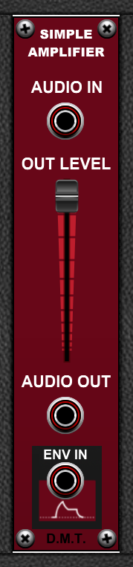

Audio In Socket
The Audio In socket is where you plug in the signal which you want to attenuate. This is usually an audio source such as an Oscillator or Noise Generator.
However, the Audio In can be used to process static DC voltages and low-frequency control voltages, too.

Audio Out Socket
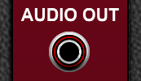
The Audio Out socket is where the module sends its processed Audio In signal, after being attenuated by the Out Level control and the Env In control voltage.

Out Level Slider
The Out Level slider acts like a global volume control for the module.
When it is at the top of its range (100.0%), the Audio Out signal is at full volume.
When it is at the bottom of its range (0.0%), the Audio Out signal is completely muted and there is silence at the Audio Out socket.
The slider works in a linear way, with 50.0% attenuation at the half-way point.

The Envelope Input Socket
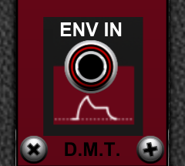
The Env In socket allows you to control the output level with an external voltage source.
It is intended to be used with the non-inverting (positive) output of the stock Cherry Audio Envelope Generator as shown below:
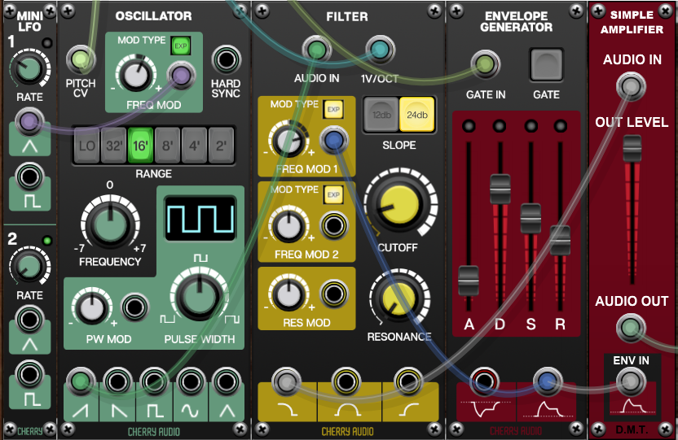
When the envelope voltage is at 0V, the Audio Out will be silent, regardless of the setting of the Out Level slider.
When the envelope voltage is at +5V, the Audio Out will reach the level set on the Out Level slider.
If you use the inverting (negative) output of the Envelope Generator, when the envelope voltage is at -5V, the Audio Out will reach the level set on the Out Level slider, but the waveform will be inverted in polarity.

Advanced Uses for the Env In Socket
The most common use for the Env In socket is, unsurprisingly, to drive it from an envelope generator. However, Simple Amplifier allows you to modulate the amplitude of the Audio In signal using any kind of voltage source:
Static DC voltage, positive or negative.
Low Frequency Oscillators, unipolar or bipolar.
Audio-rate signals, again unipolar or bipolar.

How the Simple Amplifier Works ‘Under the Hood’
The Simple Amplifier multiplies the voltage at the Audio In socket by the voltage at the Env In socket (if it is connected). The resultant voltage is then divided by 5 and attenuated by the Out Level slider’s setting. This means that the Simple Amplifier can also be used as a linear ring modulator, as shown below:
