Baba O’Lowrey from Dome Music Technologies

The Baba O’Lowrey module from Dome Music Technologies is inspired by the ‘Marimba Repeat’ function, which was a feature on several models of Lowrey electronic organ. The most famous use of ‘Marimba Repeat’ was when Pete Townshend performed the intro to “Baba O’Riley” on his Lowrey Berkshire Deluxe TBO-1. Many people assumed those rippling arpeggios were generated by his massive ARP 2500 modular synthesizer, but it was all done on the Lowrey.

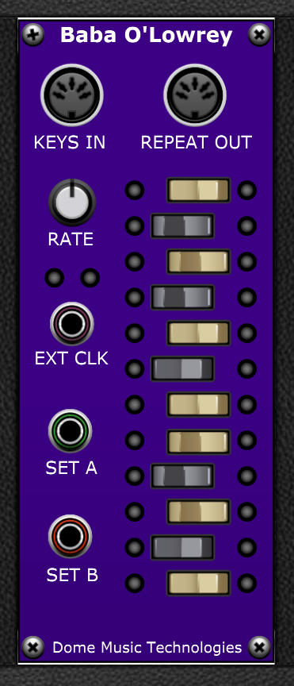

Midi In and Out Sockets
The KEYS IN socket receives MIDI note-on and note-off messages from any MIDI source in Voltage Modular. In general, you would connect this to the “FROM HOST” MIDI socket on VM’s I/O Panel, but there’s no reason why you can’t connect it to the MIDI OUT of another module (or even another Baba O’Lowrey!).
The REPEAT OUT socket sends processed MIDI note-on and note-off messages onwards to other modules which have a MIDI input. For example, you could use the Poly Octave Oscillator to generate typical electronic organ tones without requiring any further supporting modules such as filters, envelope generators or voltage controlled amplifiers. Alternatively, you could drive a third-party VSTi by using the Plug-In Host or Mini Plug-In Host modules. Of course, there’s nothing to stop you cascading multiple Baba O’Lowreys in series, which can lead to interesting results.

Bank Select Switches
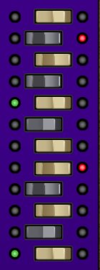
The MIDI note-on and note-off messages received are sorted into two ‘storage bins’ depending on the settings of the Bank Select Switches. If you turn your head 90 degrees to the left, you can see that the switches are laid out in the pattern of one keyboard octave (C to B). To save you pulling a muscle in your neck, here’s what it looks like in horizontal orientation:
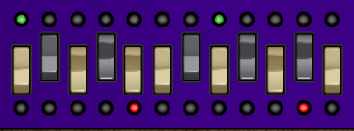
When a key’s switch is set to the left, all those notes will be stored in Bank A. When a note is played that is destined for Bank A, the green LED to the left of the switch is illuminated until the key is released. Similarly, when a key’s switch is set to the right, all those notes will be stored in Bank B. When a note is played that is destined for Bank B, the red LED to the right of the switch is illuminated until the key is released. In the image above, a C7 chord is being held down. The notes C and G have been assigned to Bank A (in green) and notes E and Bb have been assigned to Bank B (in red).
By default, the Bank Select Switches are set up to reflect the hard-wired configuration of the Lowrey organ range:
Bank A: C, C#, F, F#, G, B
Bank B: D, Eb, E, Ab, A, Bb

Clock Controls
The module works by sending out note-on messages for all the keys stored in Bank A for a short duration, then note-off messages. Then, the Bank B notes are played for a short duration, and the cycle repeats. It can be thought of as a two-stage arpeggiator which can play block chords on each step.
The RATE knob controls the speed of the cycle from 30 BPM (fully counter-clockwise) to 160 BPM (fully clockwise). Each Bank plays at a rate of 1/16th notes, and the two banks are out of phase by 1/32nd note, so it has a ‘ratcheting’ character to it, even at moderate tempos.
When Bank A is sounding, the left-hand green LED is illuminated. Conversely, when Bank B is sounding, the right-hand red LED is illuminated. At faster rates, the screen redraw rate can’t keep up, and the LEDs can appear to flash at erratic rates, unrelated to the sound.
The EXT CLK socket allows you to drive the cycle from an external clock. When this socket is disconnected, the internal clock is enabled, and cycle speed is determined by the RATE knob. When the socket is connected, the internal clock is disconnected and the RATE knob setting is ignored.
The signal at the EXT CLK input is expected to be a logic-level voltage. That is, it is considered to be logic ‘high’ when above 2.5V and logic ‘low’ when below 2.5V. Notes will play for the duration of the ‘high’ phase of the external clock, and will be released during the ‘low’ phase. When the next ‘high’ phase starts, the alternate Bank will be selected and only its held notes will play:

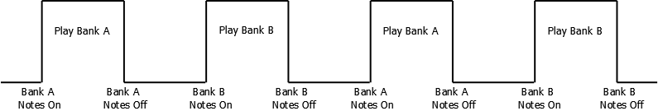

The Cycle Mode Control Sockets
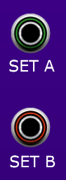
The SET A and SET B sockets are logic-level inputs which allow you to modify the Bank-switching behaviour of the internal or external clock. There are four different modes which can be selected according to whether SET A and SET B are logic-high or logic-low:

Cycle Mode 1 – Free Running (SET A low, SET B low)
Each time the clock pulses high, the alternate Bank is selected. This is the default behaviour as described in the previous section (and also reflects the default operation of a Lowrey organ).

Cycle Mode 2 – Hold Current Bank (SET A high, SET B high)
Each time the clock pulses high, the cycle does not switch to the alternate Bank. This will cause the current bank’s held notes to be repeated every 1/32nd note – i.e. at double the normal rate. This mode can be used to generate ‘ratcheting’ effects.

Cycle Mode 3 – Hold Bank A (SET A high, SET B low)
Each time the clock pulses high, the cycle will remain on Bank A. This will cause Bank A’s held notes to be repeated every 1/32nd note.

Cycle Mode 4 – Hold Bank B (SET A low, SET B high)
Each time the clock pulses high, the cycle will remain on Bank B. This will cause Bank B’s held notes to be repeated every 1/32nd note.

