Blue Velvet Soft Clipping Mixer from Dome Music Technologies

The Blue Velvet Mixer from Dome Music Technologies is a soft-clipping audio mixer which can add subtle warmth or create more extreme saturation and distortion effects. It employs the R_OpenLib oversampling library (developed by Chris Neuberger of R_Ware) to prevent harmonics from aliasing.

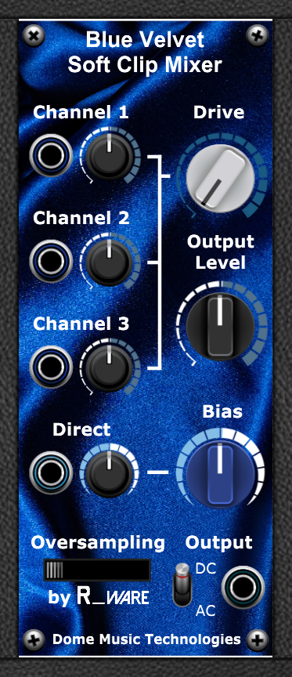

Overview
The Blue Velvet Soft Clip Mixer is an audio mixer with soft-clipping distortion. It is designed to add extra harmonics and ‘warmth’, through a process of non-linear distortion. As the input and drive levels are increased, the distortion effects become more aggressive and closer in character to brick-wall hard clipping.

Schematic
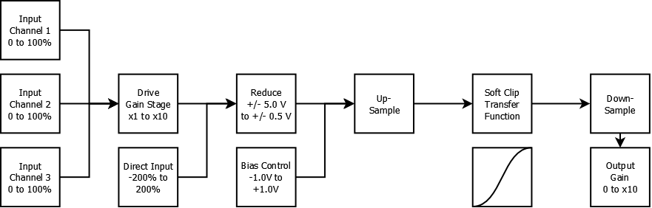
Figure 1 - Blue Velvet Block Diagram

Operation
Input channels 1 to 3 are added together and fed into the ‘Drive’ gain stage.
The Direct input channel is multiplied by the bipolar level control and added to the Drive stage output.
The combined signals are then reduced by a factor of 10 from the ‘standard’ Voltage Modular level of +/- 5.0V down to a nominal range of +/- 0.5V.
The Bias control adds a DC offset of -1.0V to +1.0V to the audio signal. This causes asymmetrical distortion, and the generation of even harmonics.
The combined signals are then passed to the up-sampling process. This will project the signal into a virtual sample rate at multiples of the standard Voltage Modular 48kHz:
Oversampling Factor | Sample Frequency
1x (No Oversampling) | 48 kHz
2x | 96 kHz
4x | 192 kHz
8x | 384 kHz
16x | 768 kHz

After up-sampling, the soft-clip transfer function is applied to the combined input signal.
Once the soft-clipping has been applied, the signal is then down-sampled and anti-aliasing filtered.
The Output Level control then boosts the soft-clipped from a maximum +/- 0.5 V up to a maximum +/- 5.0V (at knob position ‘5’), or up to a maximum +/- 10.0V (at knob position ‘10’).

Audio In Channels 1 to 3
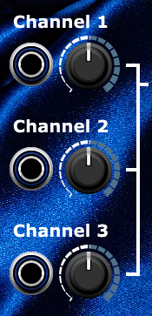
Audio input channels 1, 2 & 3 are identical. Each has an attenuator knob which is calibrated from 0% to 100% (defaulting to 50%). All three channels are added together in a linear fashion, then sent to the ‘Drive’ gain circuit.

Drive Knob
The Drive knob amplifies the combined signal from input channels 1 to 3. The gain of the drive circuit can be varied from x1 to x10. The default value is x1.

Output Level Knob
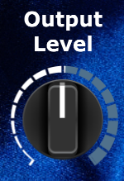
The Output Level knob controls the maximum output voltage range.
In the 7 o’clock position (0.0), the output is completely silent.
In the 12 o’clock position (5.0), the output will be in the range -5.0V to +5.0V max. This is the ‘standard’ voltage range for Voltage Modular, equivalent to 0dB.
In the 5 o’clock position (10.0), the output will be in the range -10.0V to +10.0V max.

Bias Knob

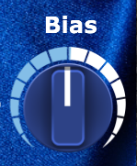

The Bias knob adds a DC offset to the signal before it is fed into the soft-clipping function. This causes the wave-shaping character to become asymmetrical, leading to a difference in the balance of odd and even harmonics.
In the 12 o’clock position (0%), the waveform is unbiased, leading to symmetrical clipping and the production of odd harmonics.
In the 7 o’clock position (-200%), the waveform is biased downwards, leading to more saturation at the negative limit. More even harmonics will be generated.
In the 5 o’clock position (+200%), the waveform is biased upwards, leading to more saturation at the positive limit. More even harmonics will be generated.

The Direct Input Channel
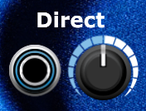
The Direct Input Channel allows you to inject a signal directly into the mix, bypassing the Drive gain stage. This can be used as an extra audio input channel with bipolar attenuation. Alternatively, it can be used with a CV input, allowing you to modulate the Bias value with an external voltage source.
In the 12 o’clock position (0%), the direct input source has no effect on bias.
In the 7 o’clock position (-200%), the direct input source modifies the Bias offset by -200%.
In the 5 o’clock position (+200%), the direct input source modifies the Bias offset by +200%.

The Oversampling Switch
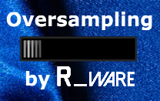
The Oversampling Switch provides 5 levels of oversampling. This can be useful for suppressing harmonics which stray above the Nyquist frequency of Voltage Modular (24kHz). The settings are (left to right):
Oversampling Factor | Sample Frequency
X1 (No Oversampling) | 48 kHz
X2 | 96 kHz
X4 | 192 kHz
X8 | 384 kHz
X16 | 768 kHz

Oversampling should only be applied if you become aware of aliasing or other unpleasant artifacts in the sound. In most cases, x2 oversampling will fix any issues and x4 oversampling should only be reserved for situations where you use very high frequency input signals with high Drive settings. x8 and x16 settings are available but will probably never be useful.
The most important thing to remember is that the Oversampling switch is not a ‘quality’ setting – it does not suddenly increase the fidelity of the signal. It should be left in the x1 position by default. Only use higher settings when you can actually hear nasty sidebands in the x1 position, and if they disappear when you switch to x2 or x4.
The oversampling algorithm used comes from the R_OpenLib library, an open-source project created by Chris Neuburger at R_Ware. R_OpenLib uses the MIT license, which means it is unnecessary to provide attribution to the original author. However, I have been looking for a developer-friendly oversampling library for many months. I want to publicly thank Chris for making it available for the Voltage Modular community, so I have added the official R_Ware logo to the front panel as a shout out to his hard work and generosity.

Output Jack and Coupling Mode Switch

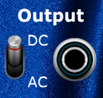

The output jack is self-explanatory. It is the mono output signal of the module.
The output coupling mode switch has two settings – “DC” (default) and “AC”.
In the DC mode, all DC offset voltages are preserved. This becomes especially evident when using non-zero values of Bias.
In the AC mode, DC offset voltages are removed. This is achieved by applying a 6dB/oct high-pass filter to the output signal. The cut-off frequency of the filter is roughly 20Hz.

The Blue Velvet Transfer Function

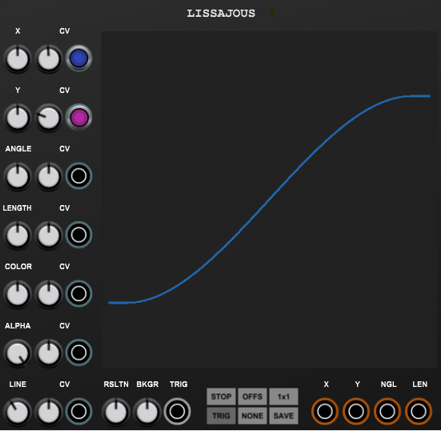

The VM Nucleus Distortion Transfer Function

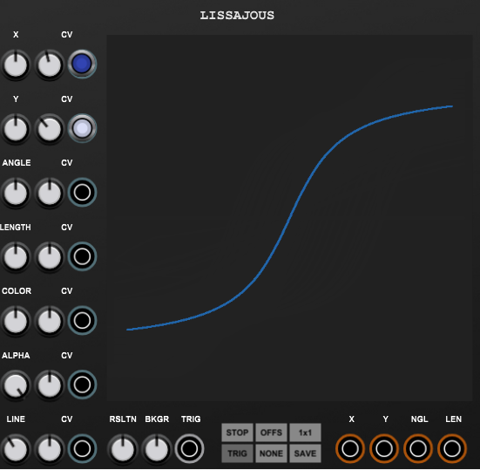

The VM900 CP3 (Rev 1) Transfer Function

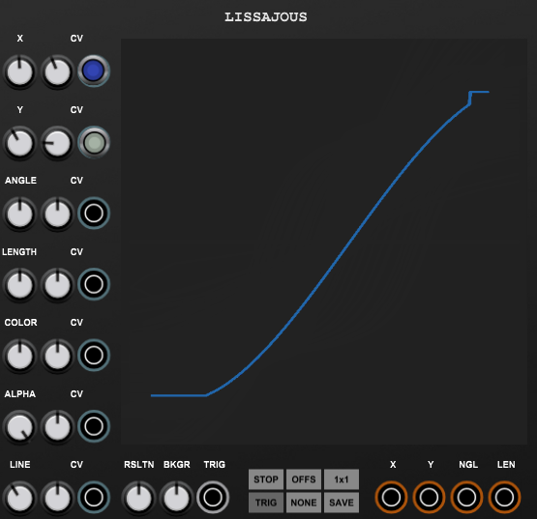

The VM900 CP3 (Rev 2) Transfer Function

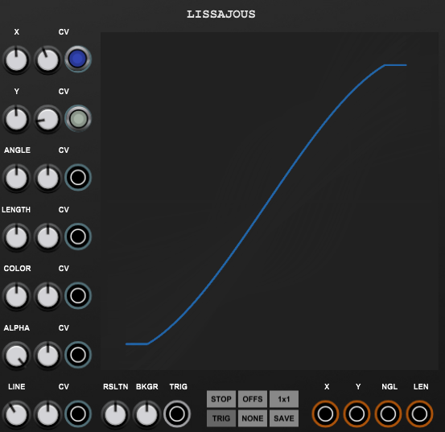

© Grant Middleton, Dome Music Technologies, January 2023

