Bully Beef Bass Oscillators from Dome Music Technologies

Bully Beef Bass Oscillators from Dome Music Technologies is a dual sawtooth oscillator. It has unique features which make it ideal for designing fat bass sounds.

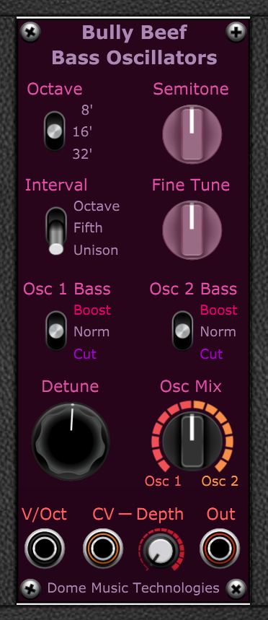

Overview
Bully Beef Bass Oscillators is a dual sawtooth oscillator designed specifically for making powerful bass sounds. It has two unique features which make it particularly suited to bass sounds:
- The two oscillators can be detuned by a constant frequency difference. This means that the phasing between them (the ‘beat frequency’) cycles at the same rate, irrespective of the pitch they are playing.
- Each oscillator has the ability to set the amplitude of the fundamental frequency component independently of the other harmonics. One problem with two oscillators tuned to the same pitch is that the fundamental frequency (the ‘first harmonic’) can completely cancel out when they are out of phase with each other. Bully Beef allows you to remove the fundamental of one oscillator so that its amplitude in the other oscillator remains constant at all times. You can also choose to boost the fundamental by an extra 6 dB for added ‘weight’.

Tuning and Interval Controls
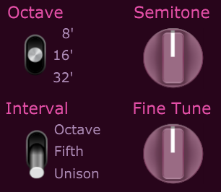
The Octave, Semitone and Fine Tune controls set the basic pitch of both oscillators.
Octave can be set to 8’ (highest), 16’ or 32’ (lowest). The Semitone knob allows you to tune +/- 12 semitones (one octave) in semitone steps. The Fine Tune knob allows you to tune +/- 1 semitone.
The Interval switch sets the musical interval between Osc 1 and Osc 2. The interval is applied to Osc 2 only, shifting its pitch in an upwards direction.
In the “Unison” position, both Oscillators are tuned to the same pitch (Ratio 1:1).
In the “Fifth” position, Osc 2 is set to a frequency exactly 1.5 times that of Osc 1 (Ratio 3:2). This differs very slightly from the interval of seven semitones in Twelve Tone Equal Temperament (1.4983 times).
In the “Octave” position, Osc 2 is set to a frequency exactly 2.0 times that of Osc 1 (Ratio 2:1).

Bass Boost / Cut Switches
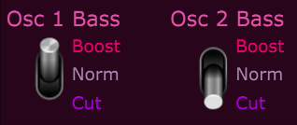
Both oscillators can select between three different waveforms, which have different harmonic content.
In the “Norm” position, the oscillator will output a standard falling sawtooth waveform:
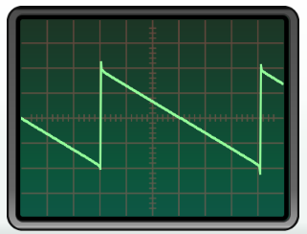
The spectrum of the “Norm” waveform looks like:
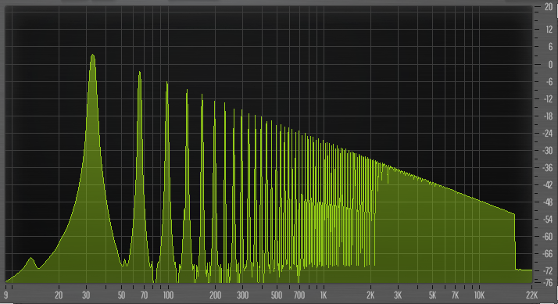
In the “Cut” position, the oscillator will output a standard falling sawtooth waveform with its fundamental component removed:
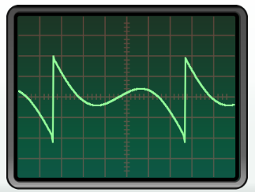
The spectrum of the “Cut” waveform looks like:
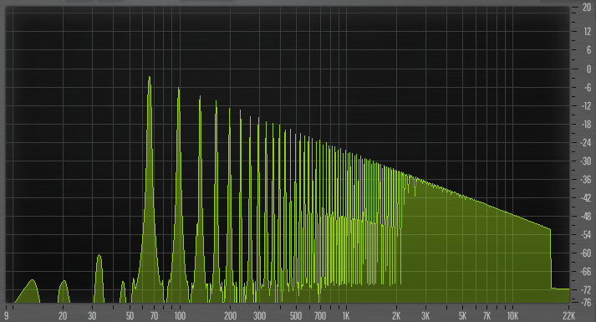
Note that the fundamental frequency (at 32 Hz) is missing.

In the “Boost” position, the oscillator will output a standard falling sawtooth waveform with its fundamental component doubled:
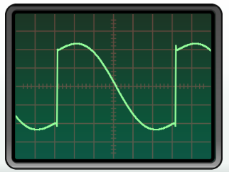
The spectrum of the “Boost” waveform looks like:
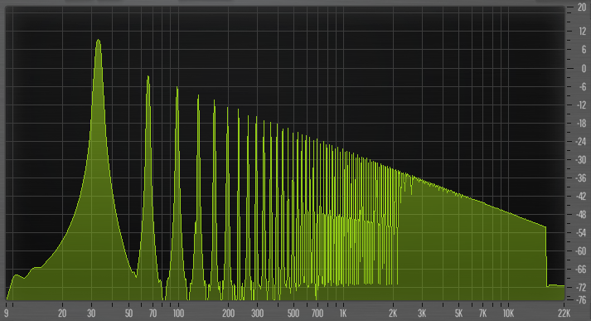
Note that the fundamental frequency (at 32 Hz) is 6 dB higher than it is in the “Norm” setting.

Detune Knob
The Detune knob sets the linear frequency difference between Osc 1 and Osc 2. The frequency difference (in absolute Hz) is constant, regardless of the musical pitch of the oscillators. This differs from most other voltage controlled oscillators, where the absolute frequency difference increases as the pitch rises. In standard VCOs, the frequency ratio between two oscillators is kept constant.
In the 12 o’clock position, the detune frequency is 0 Hz and there is no audible ‘phasing’ between the oscillators.
In the 7 o’clock position (-1.0), there is a 1Hz difference between the two oscillators. Osc 1’s frequency decreases by 0.5 Hz, while Osc 2’s frequency increases by 0.5 Hz.
In the 5 o’clock position (+20.0), there is a 20Hz difference between the two oscillators. Osc 1’s frequency increases by 10 Hz, while Osc 2’s frequency decreases by 10 Hz.

Oscillator Mix Knob

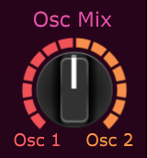

The Oscillator Mix knob adjusts the balance of the two oscillators.
In the 12 o’clock position (0), both oscillators have equal intensity.
In the 7 o’clock position (-10), only the output of Osc 1 can be heard.
In the 5 o’clock position (+10), only the output of Osc 2 can be heard.

Inputs, Output and Modulation Depth

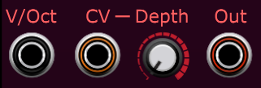

The V/Oct input is normally connected to the keyboard pitch output or sequencer output. Any volts-per-octave source can be used though, even audio signals.
The CV input allows for logarithmic voltage control of pitch.
The signal at the CV socket is attenuated by the “Depth” knob:
In the 7 o’clock position (0), the CV input has no effect on pitch.
In the 12 o’clock position (+2), +5V at the CV input will raise the pitch by 2 semitones (one whole tone).
In the 5 o’clock position (+12), +5V at the CV input will raise the pitch by 12 semitones (one octave).
The “Out” socket outputs the mixed audio signal from both oscillators.

© Grant Middleton, Dome Music Technologies, March 2023

