Fifth Dimension Phaser Factory from Dome Music Technologies

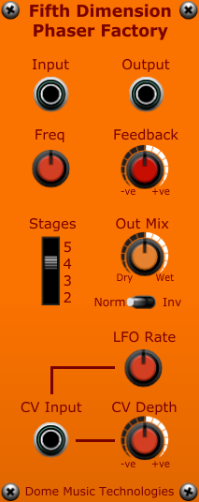

The Electro-Harmonix Small Stone Phase Shifter
The Kleiner-Kiffer module from Dome Music Technologies is inspired by the Electro-Harmonix Small Stone Phase Shifter pedal.
On the surface, the Small Stone seemed incredibly limited when compared to other phasers of the time. It only had three panel controls: A bypass footswitch, an LFO Rate knob and a tone “Color” switch. All you could really do with it is choose which of the two ‘tone colors’ you wanted, set the sweep rate, and start playing. However, the sound that came out of the Small Stone (particularly on the “HI Color” setting, was quite unlike anything else on the market. Indeed, Jean-Michel Jarre used it extensively on his albums “Oxygene” and “Equinoxe” to generate those cosmic, swirling string machine sweeps and rolling surf/wind sounds.
Internally, the Small Stone wasn’t particularly different from other contemporary phasers. It used four all-pass filter stages to perform the actual phase shifting, leading to two notches in the frequency response. However, unlike the majority of other phaser designs, Electro-Harmonix decided to use CA3094 Operational Transconductance Amplifiers (OTAs) to perform voltage control of the all-pass stages. OTAs are notoriously non-linear when compared to the more common op-amp chips of the time. This design decision may have contributed to the unique sound of the Small Stone, by introducing subtle, but pleasing, distortion into each stage of the signal chain.
Alternatively, it may have had something to do with the External Frequency Compensation input of the CA3094 providing a gentle roll-off in the top end. In the end, I had to accept that any attempts at analysing the schematic of the Small Stone and deriving a DSP model of it were beyond my skills (even though I have a degree in electronic engineering).

How to Model the Small Stone without Modelling the Small Stone
So, I decided to adopt an empirical approach in attempting to recreating the Small Stone sound; I would create a simple multi-stage phaser using ‘perfect’ all-pass filter stages, then see if I could tweak other parameters in such a way that I could get close to that magical sound.
It turned out that tweaking constant values in software, then compiling the code, then running the module in a debugging environment was a painful and horribly inefficient way of proceeding! Instead, I placed all the tweakable parameters under the control of a bunch of Voltage Modular knobs, so that I could hear the effect of parameter changes in real-time. Why I didn’t do this from the word “go” is one of the great mysteries of our time!
Anyhow, to cut to the chase, I discovered that you could get close to the Small Stone “LO Color” setting by having a 50:50 mix of dry to phase-shifted sound, and having zero feedback in the phase-shifting chain. The “HI Color” setting, in turn, could be approximated by setting the output mix to 66.7% wet and setting feedback to around +0.8 (80%).

The Kleiner-Kiffer Module and Fifth Dimension as Complementary Devices
Once I transferred these values to constants within the Kleiner-Kiffer code, I was pleasantly surprised by how close I had got to a reasonable Small Stone character. I thought that other VM users (and developers) might be interested in using the experimental, tweakable, module for themselves. So, here it is, pretty much exactly as I used it during development. I hope you can find it useful and inspiring, too.

Input and Output Sockets
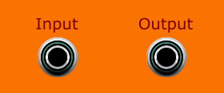
There’s not a lot to say about these. Mono audio signal goes into the Input socket and mono processed sound comes out of the Output socket!
I decided to make Fifth Dimension a strictly mono device. Phasers aren’t quite as suited to generating pseudo-stereo output as other devices such as flanger, chorus, etc. The best way to get stereo effects is to run two instances of Fifth Dimension in parallel, but to modulate them with different control voltages. In particular, modulating from the same external LFO, but with opposite polarity of CV depth, leads to some fantastic stereo results (see later…).

Centre Frequency and Feedback Knobs
The Freq knob controls the corner frequency of each all-pass filter stage. This is the frequency at which incoming signals will be phase-shifted by 90 degrees. The classic phaser ‘notch’ happens when two all-pass filters with the same corner frequency are cascaded, leading to signals at the corner frequency to be phase-shifted by a total of 180 degrees (inverted). When this inverted signal is mixed with the original, dry signal, you get complete destructive interference and that signal component is cancelled. As you add more all-pass stages, the maths becomes a little more complicated (see later…). To be honest, it’s best just to use your ears and tweak the Freq knob until you find an effect that sounds good to YOU!
The Feedback knob allows you to take some of the phase-shifted signal and mix it back in with the dry signal at the start of the chain of all-pass filters. This has the effect of increasing resonance or ‘peakiness’ of the phaser response. Once again, there are no hard-and-fast rules about whether positive or negative feedback sounds best. Just use your ears!

Phase Shift Stages Switch, Output Mix Knob and Polarity Switch
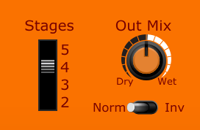
OK, this is where things start to go down a rabbit hole (or three)! The effect of these parameters, and the way they interact, can be unintuitive so yes, you’ve guessed it – it’s time to rely on your ears again!

The Maths Bit!
Each all-pass filter stage will shift signals at 0Hz by 0 degrees and signals at infinity Hz 180 degrees. At the corner frequency, signals will be shifted by 90 degrees. This means that, in practical terms, you can never achieve a phase shift of 180 degrees using only one all-pass filter stage.
In order to get a ‘notch’ in the output spectrum, signals have to be shifted by 180 degrees (or 540 degrees) when the Polarity switch is in the “Norm” position. When the Polarity switch is in the “Inv” position, you will get notches at 0 degrees and 360 degrees. As you increase the number of stages, you will get notches appearing at frequencies where the phase shift = 180 / (number of stages). This table shows where the notches will end up for the different switch settings:
n All-Pass Filter Stages | Notch 1, Normal  (180 degrees / n) | Notch 2, Normal  (540 degrees / n) | Notch 1, Inverted  (0 degrees) | Notch 2, Inverted  (360 degrees / n)
2 | Freq (90 deg) | N/A | 0 Hz | Infinity Hz
3 | Freq (60 deg) | Infinity Hz | 0 Hz | Freq (120 deg)
4 | Freq (45 deg) | Freq (135 deg) | 0 Hz | Freq (90 deg)
5 | Freq (36 deg) | Freq (108 deg) | 0 Hz | Freq (72 deg)
In addition, there is a sort of ‘virtual third notch’ at infinity Hz when configured for (4 Stages, Inverted) and (5 Stages, Normal). This leads to a gentle low-pass response for these settings. The same applies to the ‘virtual second notch’ when configured for (2 Stages, Inverted) and (3 Stages, Normal). When the Polarity switch is in the “Inv” position, there will always be a ‘virtual notch’ at 0 Hz, leading to a gentle high-pass response.
With the Freq knob set to its centre (12 o’clock) position (All-pass corner freq = 742 Hz):
Freq (36 deg) = 244 Hz, Freq (45 deg) = 312 Hz, Freq (60 deg) = 432 Hz, Freq (72 deg) = 544 Hz, Freq (90 deg) = 742 Hz, Freq (108 deg) = 1036 Hz, Freq (120 deg) = 1308 Hz, Freq (135 deg) = 1810 Hz.

Example Frequency Spectrum Plots of Different Switch Settings
It’s easier to interpret the table above when shown the effects visually. Over the next few pages is a group of plots of white noise with an Out Mix of 50:50, Freq in centre (12 o’clock) position, Feedback at 0 (12 o’clock). Plots are shown for 2, 3, 4 and 5 all-pass stages, and with the Polarity switch in the “Norm” (normal / non-inverted) and “Inv” (inverted) positions.

2 Stages, Normal (Notch filter)
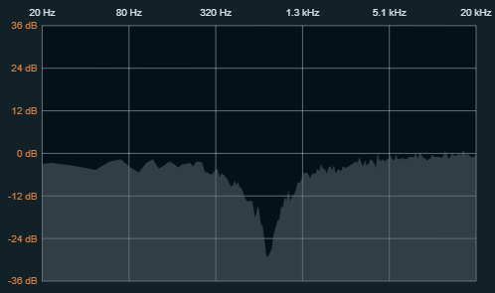

2 Stages, Inverted (Bandpass filter)
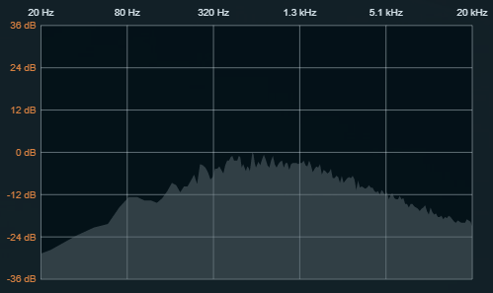

3 Stages, Normal (Notch with gentle lowpass response)
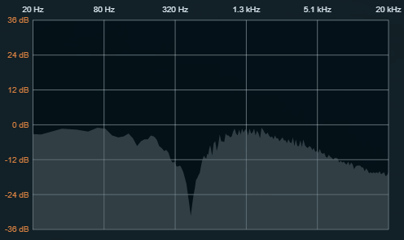

3 Stages, Inverted (Notch with high-pass response)
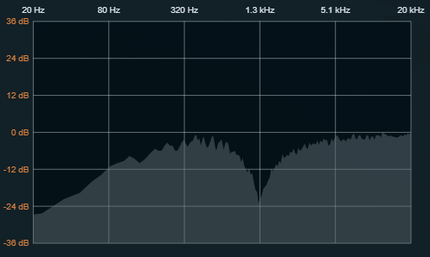

4 Stages, Normal (Two notches)
This is an approximation of the Small Stone “LO Color” response.
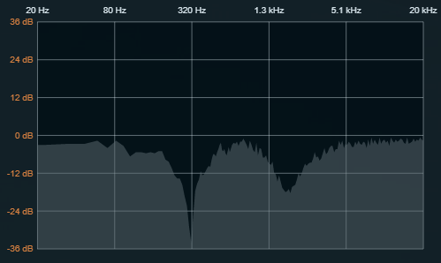

4 Stages, Inverted (Two bandpass peaks with sharp notch between)
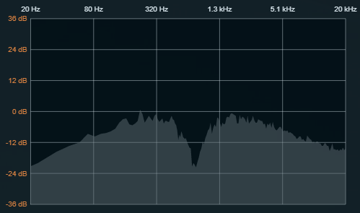

5 Stages, Normal (Two notches with low-pass response)
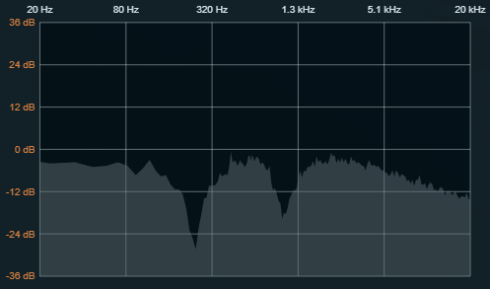

5 Stages, Inverted (Two notches with high-pass response)
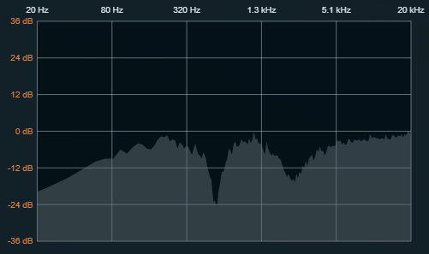

Here are two examples of a resonant phaser. The first is the plot of a 4-stage phaser, inverted mix, with Feedback set to -69.3% and Out Mix set to 66.3%:

4 Stages, Inverted, Resonant (Two resonant peaks, sharp notch)
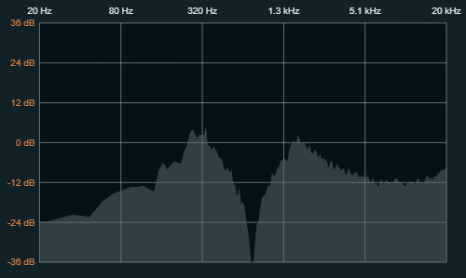

The second is the plot of a 4-stage phaser, normal mix, with Feedback set to +82.7% and Out Mix set to 68.7%:

4 Stages, Normal, Resonant (Sharp resonant peak, two notches)
This is an approximation of the Small Stone “HI Color” response.
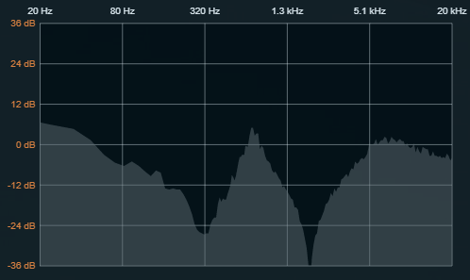

Voltage Control and Modulation Section
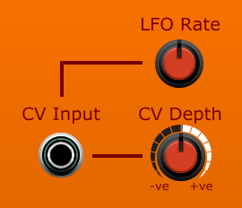
Fifth Dimension has an internal triangle-wave LFO for those classic swept phaser sounds. Rate is controlled by the LFO Rate knob, from 0.04 Hz (25 seconds per cycle) to 12 Hz. The CV Depth knob varies the depth of sweep from -100% (7 o’clock position) through 0 (12 o’clock position) to +100% (5 o’clock position). When using the internal LFO, the polarity of the CV Depth knob doesn’t really matter, as the triangle wave is bipolar and symmetrical.
If you want to control the phaser sweep via an external control voltage, you should connect the voltage source to the CV Input socket. This will disable the internal LFO. The CV Depth knob controls the amount of influence the external CV has on the centre frequency. At +100% CV Depth, one volt of CV input will increase the centre frequency by one octave. Similarly, at -100% CV Depth, one volt of CV input will decrease the centre frequency by one octave.
An interesting mono-to-stereo effect can be achieved by using the same external CV source to control two instances of Fifth Dimension, but setting the CV Depth knobs to be the opposite polarity:
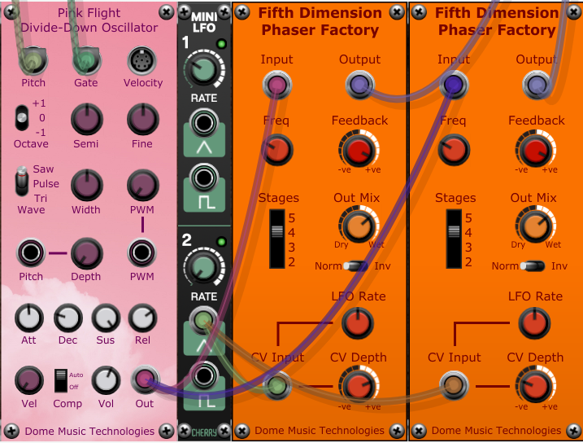

© Grant Middleton, Dome Music Technologies, August 2022

