Solaris Ensemble from Dome Music Technologies

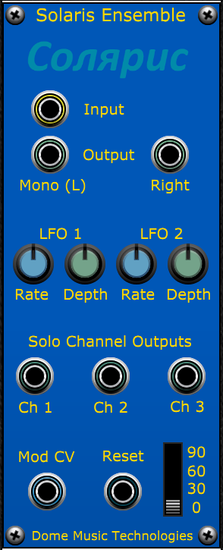

History of the ‘Solina Sound’
The Solaris module from Dome Music Technologies is inspired by the ensemble effect built in to the ARP Solina string machine. The ARP Solina was actually a re-badged version of the “Solina Ensemble” which had been developed by the Dutch organ manufacturer Eminent. Although many 1970s artists used the ARP Solina for generic pop string sounds, it could be argued that Jean Michel Jarre really brought that silky ensemble sound deep into the sphere of Kosmische Musik on his albums Oxygène (1977) and Équinoxe (1978). When he played his Eminent 310 Unique organ through an Electro-Harmonix Small Stone Phaser with tape echo, it created a template for swirling psychedelic spacey pads.

Solina Secrets
The sound of the Solina Ensemble circuit is quite different to most chorus units of the time, as is its internal architecture. Its unique (“Unique”?) sound is created by running the input signal through three parallel Bucket-Brigade Delay lines. Two multi-phase sine wave LFOs are used to modulate the delay times of the BBDs. Each LFO has three phase-shifted outputs and they run at different rates and with different depths of modulation. All of these features combine to create a chorus effect which ripples and shimmers in a consistent manner, but without the regular, cyclic nature of other contemporary designs.
This is an overview of how Solaris goes about recreating the Solina sound.

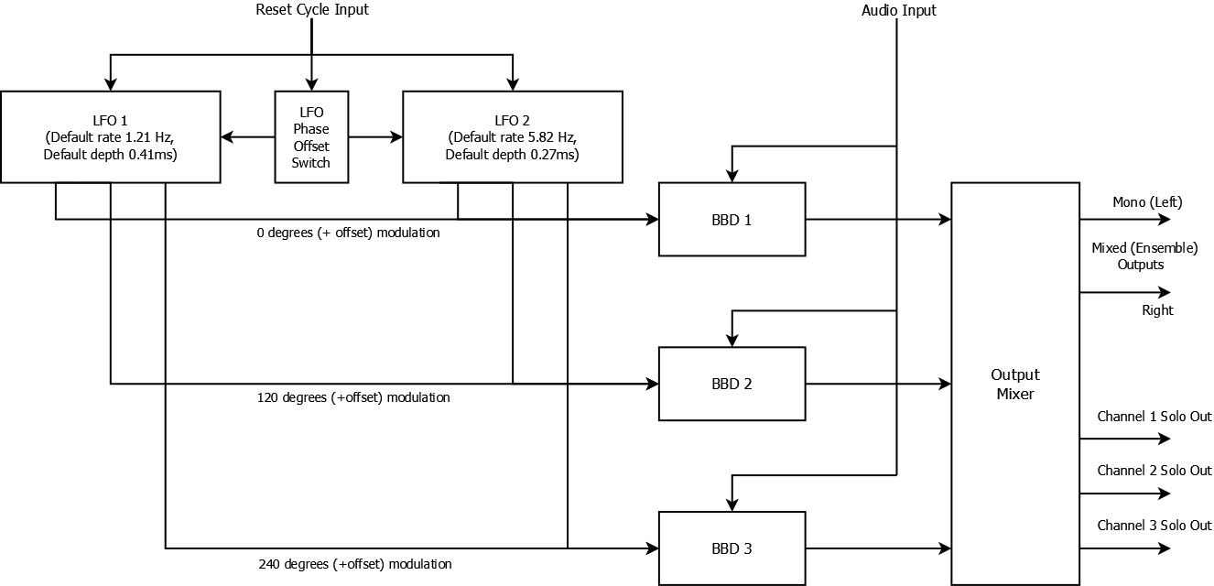
Figure 1 - Solaris Ensemble Block Diagram
Note that none of the original audio input appears at the Output Mixer, hence there is no need for a Wet/Dry mix knob.

Audio Input and Mixed (Ensemble) Outputs
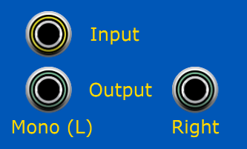
Solaris has a single (monaural) audio input. If it is desired to process a stereo signal pair, two Solaris modules can be operated in parallel. The LFO Cycle Reset input (see later) can be used to ensure that the LFOs in all Solaris modules are kicked off at the same point in their cycles.
The main outputs feature a mix of all three modulated BBD signals, giving that classic ‘ensemble’ sound. To use the Solaris in classic monaural mode, plug your output cable into the “Mono (L)” socket and leave the “Right” socket disconnected. To use in stereo mode, plug cables into both “Mono (L)” and “Right” sockets.
In mono mode, the “Mono (L)” socket signal = (BBD1 + BBD2 + BBD3) / 3.
In stereo mode, the “Mono (L)” socket signal = (2 * BBD1 + BBD2) / 3, while the “Right” socket signal = (2 * BBD3 + BBD2) / 3.
As a result of splitting the BBD output signals in stereo mode, the ensemble sound can be slightly ‘thinner’ than when used in mono mode (but still perfectly serviceable!). You can make a richer stereo signal by running two mono Solaris modules in parallel and introducing a phase offset to the second module’s LFOs via the Phase Offset switch (see later).

Solo Channel Outputs
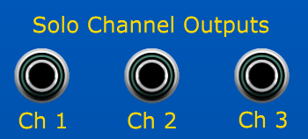
The solo isolated outputs from each BBD are presented on the front panel, as well as being added to the main ensemble mix outputs. This allows you to treat each BBD’s output as a separate signal (at full amplitude). Each solo signal will exhibit only pitch modulation effects, and will be free from the constructive and destructive interference patterns typical in chorus, flanging and phasing. There is an average time delay of a little over 1.0 milliseconds between the signal arriving at the input socket and appearing at a solo output.
What does it sound like if you low-pass filter Ch 1, high-pass filter Ch2 and leave Ch3 unaffected? I don’t know, but with Solaris in your Voltage Modular Library, you can find out!

LFO Rate & Depth Controls
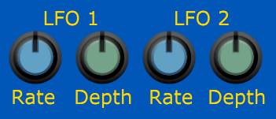
The Rate and Depth settings for LFO 1 & LFO 2 can be independently adjusted. The default values of these settings are applied at the 12 o’clock position. They are:
LFO 1 Rate = 1.21 Hz LFO 2 Rate = 5.82 Hz
LFO 1 Depth = 68% LFO 2 Depth = 69%
These settings were fine-tuned to make Solaris sound as close as possible to the Solina ensemble sound. Due to the sensitive interactions between the four LFO parameters, it can take a fair bit of experimentation to find a ‘sweet spot’ – it’s more of an art than a science. Here are some guidelines:
1. If you set the two LFO rates too close to one another, you can hear audible ‘beating’ in the modulation depth, just like two VCOs when detuned slightly.
2. Try to find LFO rates which are not integer multiples of one another. When they are not related by a simple ratio, the ensemble effect is richer, more fluid and less obviously cyclical.
3. As you increase LFO rates, the pitch-shifting effect becomes more pronounced. LFO 2 covers a higher range of frequencies than LFO 1, so its highest depth setting has been reduced to make up for this. If you DO want extreme pitch-shifting effects, use faster rates on LFO 1.
4. When the depth of one LFO is set to zero, it can sound like the active one is running at three times the displayed frequency. This is because the three phases are each separated by 120 degrees. Use a solo output if you want to generate single vibrato effects at the displayed frequency.
5. When the effects of one LFO are heard in isolation (i.e., the other depth is set to zero), the modulation can sound quite extreme. It’s counter-intuitive, but introducing the other LFO can make the sound less extreme. Try listening to a sound with the default panel settings. Then try turning one of the LFO depths down to zero. The sound can become obviously cyclical, or even quite harsh and unpleasant. Somehow, mixing two horrible modulations together becomes lush and silky!

LFO | Min Rate | Default Rate | Max Rate | Max Delay Modulation Depth
LFO 1 | 0.25 Hz | 1.21 Hz | 5.0 Hz | +/- 29 samples (+/- 0.60 ms)
LFO 2 | 1.0 Hz | 5.82 Hz | 10.0 Hz | +/- 19 samples (+/- 0.40 ms)

Modulation Control Voltage Input
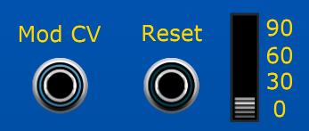
The Mod CV input allows you to use a control voltage of 0V to 5V to attenuate the LFO depth settings on the front panel. If the input CV is 0V, there will be no LFO modulation, and the sound at all output sockets will be exactly like the original, but delayed by about 1ms. When the input CV is 5V, the LFO modulation depth will be set to the value of the Depth knobs on the front panel. Note that CV below 0V or above 5V is ignored.
Plugging the Mod Wheel signal into the Mod CV makes for a nice performance control. This configuration lets you morph between a static copy of the input signal and the full-on ensemble effect. Aftertouch can also be a useful real-time performance option.
Voltage control by envelope generator, external LFO or step sequencer, also opens up the possibilities of morphing the ensemble effect automatically as a note evolves.

Inter-Module Synchronisation
If you are considering using two (or more) Solaris modules to perform parallel processing, it is important to synchronise the internal LFOs to each other. This is where the Reset input socket and phase offset selection switch come into play.
When a positive pulse (going from below 2.5 V to above) is received at Reset, both LFOs initialise to the phase selected on the Phase Offset switch. Think of it as a Hard Sync input to the Solaris LFOs! When designing a patch with parallel Solaris modules, it is useful to have a pulse source handy. I recommend the (free of charge) Buttons 2/1 module by P.moon:
https://store.cherryaudio.com/modules/buttons-21
Remember that both LFOs output three different sine waves each, with output channels separated by 120 degrees. This table shows the initial phase angle which the three output channels will be set to for the different offset switch settings:
Phase Offset Switch | Channel 1 Phase | Channel 2 Phase | Channel 3 Phase
0 | 0 | 120 | 240
30 | 30 | 150 | 270
60 | 60 | 180 | 300
90 | 90 | 210 | 330

If you wanted to create a rich stereo effect by using the mono outputs of two Solaris modules panned hard left and hard right, it is important that the LFOs in both modules DO NOT coincide with each other. This would lead to EXACTLY the same signal being sent to Left and Right monitors, making it appear in the centre of the stereo image. For this reason, set the phase offset of the left channel to be 0 degrees, and the phase offset of the right channel to be 60 degrees. This will effectively give you 6 BBDs, driven by 4 LFOs spaced at 0, 60, 120, 180, 240 and 300 degrees. You can extend this principle to four Solaris modules, with 12 BBDs and 8 LFOs separated in 30-degree increments!
Solaris will reset LFOs to the Phase Offset Switch position under any of these conditions:
1. Whenever a positive pulse is received at Reset.
2. Whenever you change the Phase Offset Switch position.
3. Whenever you reload a saved patch. This means that you don’t have to use any kind of pulse source to ensure that the correct initial phase offset is applied to a loaded patch.

Further Reading / Resources

Gordon Reid’s Synth Secrets series in Sound on Sound Magazine had an article dedicated to the various types of chorus and ensemble units used throughout the ‘70s:
https://www.soundonsound.com/techniques/more-creative-synthesis-delays

Playing Oxygene pt 1 on an Eminent 310, Small Stone phaser and delay:
https://www.youtube.com/watch?v=hUkL9osyVv8

Eminent Solina String Ensemble and Sovtek Small Stone Clone:
https://www.youtube.com/watch?v=_xF82qkBQu4

© Grant Middleton, Dome Music Technologies, July 2022

