The Stringer Seventy-Six Paraphonic Construction Kit
from Dome Music Technologies

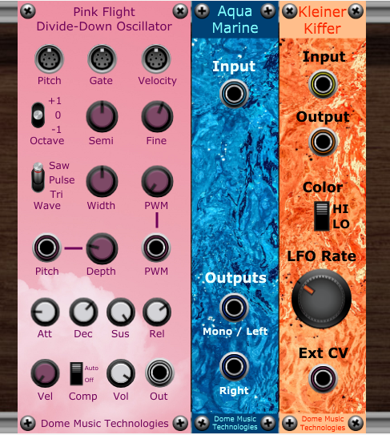

Introduction
Stringer Seventy Six is a set of modules which allow you to build sophisticated polyphonic and paraphonic instrument designs, such as string machines, combo organs, brass ensembles, electric pianos, etc.
It contains:
Pink Flight Divide-Down Oscillator - a polyphonic oscillator with velocity sensitivity and individual ADSR envelopes for each voice channel.
Aqua-Marine Ensemble Generator - a tri-chorus ensemble generator, modelled on the Eminent Solina circuit. A preset version of the Solaris Ensemble by Dome Music Technologies.
Kleiner-Kiffer Phaser - a simple phaser, modelled on the sound of the EHX Small Stone.
Stringer Seventy Six was designed to be a low-cost introduction to polyphony within the Voltage Modular environment. You can build very rich and lush patches using only this bundle together with the free-of-charge Voltage Modular Nucleus Edition and the Dome Music Technologies Freebie Collection.
All the presets in the included preset pack were also designed to be used with only free-of-charge modules.

Pink Flight Divide-Down Oscillator
The Pink Flight Divide Down Oscillator provides the basic sound source for building your own polyphonic / paraphonic instruments, such as string machines, electric pianos, brass ensembles, paraphonic synths, combo organs, etc.

Polyphonic Inputs and Tuning Section

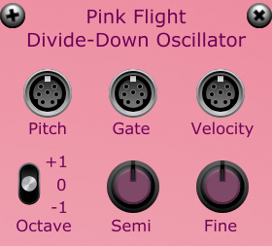

Pink Flight connects to the Poly Pitch, Poly Gate and Poly Velocity sockets on the Voltage Modular Poly Sources panel. You can also set the number of polyphonic voices (from 1 to 16) through this panel. If the velocity socket is disconnected, each voice will sound at full intensity when triggered.
Basic pitch (footage) can be set over a 5 octave range by using the Octave switch (+/- one octave) and the Semi knob (+/- 12 semitones). Fine detuning is available over a range of +/- one semitone through the Fine knob.

Waveform Selection and CV Modulation Section

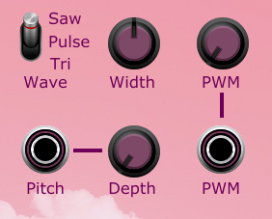
Pink Flight offers three waveform types - sawtooth, triangle and variable pulse (with Pulse Width Modulation).
The Width knob allows you to set the static width of the pulse waveform, from 0.5% to 99.5%. Pulse Width Modulation is available by connecting an external modulation source to the PWM socket and setting depth of modulation through the PWM knob. At the 7 o’clock position, the modulation input has no influence. At the 5 o’clock position, a modulation input of +5V will increase the pulse width by 50%.

The Envelope, Velocity and Volume Control Section
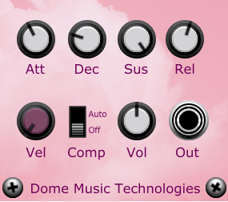
Each voice channel features individually-articulated ADSR amplitude envelopes and individual velocity response. Attack, Decay and Release times can be varied between 1ms and 10 seconds. Velocity sensitivity (touch response) can be varied via the Vel knob - from flat (full volume, irrespective of key velocity) to fully dynamic (zero volume for softest touch, full volume for hardest touch). If the velocity socket is disconnected, all voices will sound at full intensity when triggered, irrespective of the setting of the Vel knob.
Output amplitude is controlled by the Vol knob, with a range of 0 to 200% (+6dB). When the Comp (voice count compensation) switch is in the Auto position, it will reduce volume automatically as more polyphony is added, to avoid potential input signal overload on downstream modules.

Aqua-Marine Ensemble Generator
This is a preset version of the Solaris Ensemble. Solaris itself was modelled after the Eminent / Solina ensemble generator and offered several customisation options on the front panel. Aqua Marine is set permanently to the default 'Solina' sound.

Input Socket
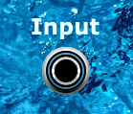
Aqua-Marine only processes monoaural audio sources. Generally speaking, it’s better to mix stereo signals down to mono before processing them with Aqua-Marine, rather than using two modules in parallel on the the left and right channels. This is just a rule-of-thumb, though; do whatever sounds best to YOU.

Output Sockets
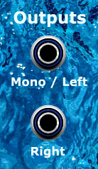
For a rich-sounding mono output, just use the Mono / Left output socket by itself, with the Right socket disconnected.
For a wider (but slightly less rich) stereo output, pan the Mono / Left output and Right output hard left and right respectively.
You can bypass the effect by right-clicking on the front panel and selecting option "Bypass Module".

Kleiner-Kiffer Phaser
This is a very simple-to-operate phaser inspired by the EHX Small Stone. I say "inspired by" because there's something magical about the original pedal that seemed to defy analysis by a mere mortal like me. However, I think I managed to capture the basic spirit of its iconic, cosmic sound. If you want a truly authentic replication of the Small Stone’s sound, I can heartily recommend “Big Rock” by ArtsAcoustic.

Input and Output Sockets
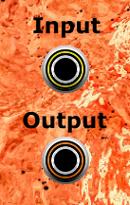
Kleiner-Kiffer is a strictly mono effect. It IS possible to run two in parallel to process left and right channels of a stereo signal independently. However, if you attempt this, it is strongly recommended that you use an external control voltage, rather than depending on synchronisation of the free-running internal LFOs.

“Color” Switch
The original Small Stone was a four-stage allpass design, meaning that it had two notches in its output frequency spectrum. Kleiner-Kiffer is the same.
Small Stone offered two tone colours – “HI” and “LO”. The “LO” setting was a more subtle phasing effect, with zero resonance. The “HI” setting generated a more strident phasing effect, due to the high feedback / resonance levels. The modulation depth was also expanded compared to the “LO” setting, so that peaks and notches would extend higher and lower into the frequency spectrum.
Kleiner-Kiffer’s internal parameters have been tweaked to be as close as possible in behaviour to the original Small Stone’s ‘Color’ settings.

LFO Rate Knob
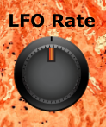
The original Small Stone, in common with many early stomp-box phasers, gave you very limited control over parameters. In fact, all you can do is tweak the sweep cycle rate of its internal triangle wave LFO. This limitation has been carried forward into Kleiner-Kiffer. The internal LFO covers roughly the same frequency range as the original – from 0.04 Hz (25 seconds per cycle) up to 12 Hz.

External Control Voltage Socket
The Ext CV socket allows you to override the internal LFO, and control the centre frequency of the phaser through an external voltage source. This could be another LFO (perhaps using sine wave instead of triangle), an envelope generator, a sequencer, etc. By using a static DC voltage as the external control, you can change the centre frequency manually.

One interesting effect is to set up two instances of Kleiner-Kiffer and feed them with inverted and non-inverted signals from the same LFO:
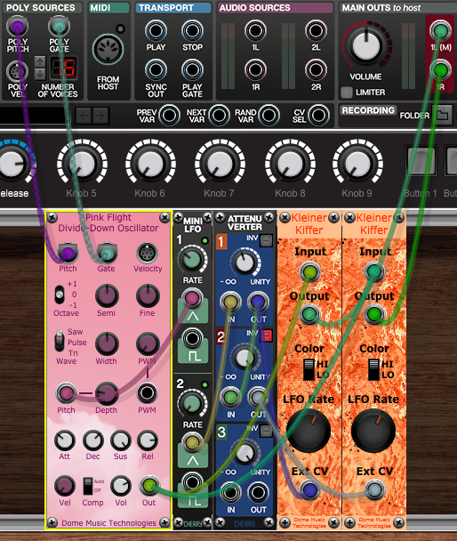
This gives a wide, swirling stereo effect which can sound very cosmic, especially on the ‘HI Color’ setting.

© Grant Middleton, Dome Music Technologies, August 2022

