The RAT Pack Bundle from Dome Music Technologies
The RAT Pack is a duo of modules based on a physical model of an RC (Resistor-Capacitor) charge-discharge circuit. Each module has a central core function:
The B.I.G.R.A.T. - An LFO / VCO / Simple envelope generator
The S.M.O.L.R.A.T. – A Slew Limiter / Sample & Hold with some unique features and modes of operation.
In addition, each module can be configured to operate far ‘beyond specification / original intention’. In this document and the example presets collection, I hope to demonstrate that these modules can be useful, multi-faceted tools and a source of inspiration in your modular adventures. So far, I have come up with patches which use Big Rat as:
Free-running LFO
Gated / Synced LFO
ASR envelope generator
AD envelope generator
Repeating AD envelope generator
Ratcheting envelope generator / LFO
Zero-Crossing Detector
JMJ VCS3 ‘laser zaps’ generator
Complex waveshape VCO
Syncable VCO

I must state that when Big Rat is operating as an audio-rate VCO, it starts to become a little unstable in tuning once you get above Middle A. Also, no effort has been made to avoid alias frequencies when instantaneous jumps in output voltage are generated. However, these limitations can be seen as features, not bugs, as it starts veering off into wild and unpredictable territory. If you want well-behaved, law-abiding VCOs, there are plenty to choose from within the Voltage Modular universe!

So far, I have managed to coax the following uses out of Smol Rat:

Asymmetric speed / note-jump distance portamento controller
Gated / legato-switched portamento controller
‘Duophonic’ keyboard controller
Sample, Hold & Slew unit
DC bias filter / AC coupler
‘On The Run’ hi-hat envelope generator
LFO wave shaper
Audio-rate wave shaper with clipping behaviour
Audio-range 6dB/oct low-pass and high-pass filter
Low-frequency 6dB/oct low-pass and high-pass filter
All-pass filter stage in low-freq and audio ranges
Cascading filter stages to create bespoke filter configurations / slopes

In general, Smol Rat behaves very well throughout the entire audio range, unlike its Big Brother!

Big Rat User Guide
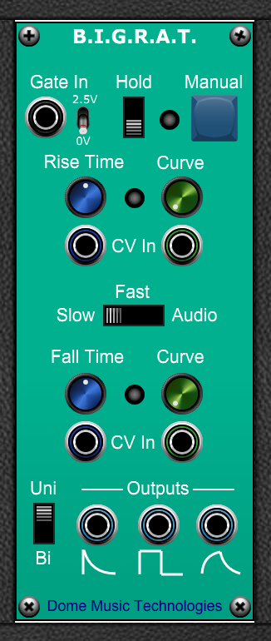

Gate Section
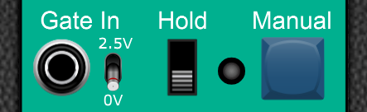

Gate In Jack
External gate input. ‘Off’ when voltage is <= 0.0V, ‘On’ when voltage > 0.0V. If you want to change the ‘On’ threshold voltage to a positive value, simply patch in a DC Source with the corresponding negative value.

Gate Detection Threshold Switch
This switch determines whether the Gate In signal is high when it’s above 0V (default position) or above +2.5V. Most modules within the Voltage Modular ecosystem operate with a logic high signal being over +2.5V, so this position is more compatible with the ‘standard’.

Hold Switch
Gate on continuously when in the ‘Hold’ position. Useful for free-running LFO / VCO applications.

Gate On LED
This LED illuminates Red when the gate is high, whether that comes from the Gate In, Hold Switch or Manual Button

Manual Button
A momentary action button which sets gate ‘On’ when pressed and ‘Off’ when released.
Note that all Gate sources are logical-OR’d together, so if any one of them is ‘On’ then the other sources are ignored.

Timing Control Section
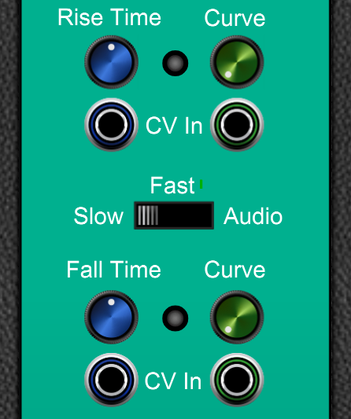

Time Base Multiplier Switch
Slow: x 1.0 second
Fast: x 0.1 second
Audio: x (1/131) second (Tuned roughly to musical note C for keyboard CV tracking)

Rise Time / Fall Time Knobs
The time taken to execute the Attack or Decay phase. Note that increasing these time periods (by rotating the knob clockwise) lowers the frequency when used as an LFO or VCO. Values range from 0.001 x time base to 10.0 x time base, with value 1.0 x time base at the 12 o’clock position.

Rise / Fall LEDs
The Rise LED illuminates green when in the Rise phase of the cycle. The Fall LED illuminates green when in the Fall phase of the cycle. When in the Rest phase, both LED are off.

Curve Knobs
These knobs control the shape of the curve of the Attack and Decay transients.
At position 0 (fully counter-clockwise), the curve is at its most steep, representing a charge/discharge curve shape over one RC time period.
As the Curve value increases, the shape of the curve becomes softer and more rounded. Also, the time period of the related Rise / Fall phase will increase.
At position 10 (fully clockwise), the curve becomes asymptotic and will sustain at the final phase value for as long as the gate is ‘On’. In order to create ASR-style envelope shapes, set Rise Curve = 10. For non-repeating AD-style envelopes ensure that Rise Curve is <10 and that Fall Curve = 10.

Rise / Fall Time CV Inputs
The CV inputs under the Time knobs operate on a V/Oct basis. That is, for every increase in control voltage of 1 volt, the time period will be cut in half (thereby raising frequency by one octave). Similarly, a decrease of 1 volt will double the time period (and lowering frequency by one octave).

Rise / Fall Curve CV Inputs
The CV inputs under the Curve knobs operate on an additive basis with the knob setting. The control voltage is added to the value of the knob setting and the result limited to the range 0 to 10.

Output / Polarity Section
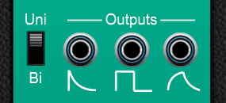

Polarity Selection Switch
When switched to “Uni”, all outputs are unipolar, with values from 0V to +5V.
When switched to “Bi”, all outputs are bipolar, with values from -5V to +5V.

Curve Output Jack (Right hand side)
Polarity | Rise / Attack Phase | Fall / Decay Phase | Rest Phase
Unipolar | 0V to +5V | +5V to 0V | Return to 0V
Bipolar | -5V to +5V | +5V to -5V | Return to 0V

Square / Pulse Output Jack (Middle)
Polarity | Rise / Attack Phase | Fall / Decay Phase | Rest Phase
Unipolar | Steady +5V | Steady 0V | Steady 0V
Bipolar | Steady +5V | Steady -5V | Steady 0V

Falling Ramp Output Jack (Left Hand Side)
Polarity | Rise / Attack Phase | Fall / Decay Phase | Rest Phase
Unipolar | +5V to 0V | +5V to 0V | Return to 0V
Bipolar | +5V to -5V | +5V to -5V | Return to 0V

Note that the falling ramp wave will appear to be twice the frequency of the other waves when Rise and Fall times are of equal duration.

Smol Rat Front Panel
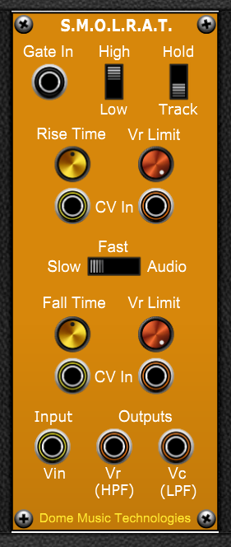

Gate Section
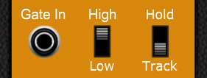

Gate In Jack
External gate input. ‘Off’ when voltage is <= 0.0V, ‘On’ when voltage > 0.0V. If you want to change the ‘On’ threshold voltage to a positive value, simply patch in a DC Source with the corresponding negative value.

Gate Polarity Switch
Determines whether the gate function (Hold or Track) is active when the external gate signal is ‘On’ (High) or ‘Off’ (Low). To operate in standard unconditional slew mode under all conditions, unplug all cables from the Gate In jack and set the Polarity switch to High. To bypass slew mode whilst the module is still in-circuit, unplug all cables from the Gate In jack, set the Polarity switch to Low and set the Gate Function switch to Track.

Gate Function Switch
When set to the Hold position, the Capacitor voltage output will freeze at its current value. The Resistor voltage jack will output (V_{IN} – V_{C}). Note that when Hold mode switches back to normal mode (when Gate becomes inactive), the slew will pick up from the frozen value and start heading towards V_{IN}. It will not jump directly to V_{IN} as would happen with a ‘traditional’ Sample & Hold.
When set to the Track position, the Capacitor voltage output will be an exact copy of V_{IN}. The Resistor voltage jack will output 0.0V at all times. Legato-controlled portamento can be configured by setting the Polarity switch to ‘Low’ and Function switch to ‘Track’.

Timing / Limit Control Section
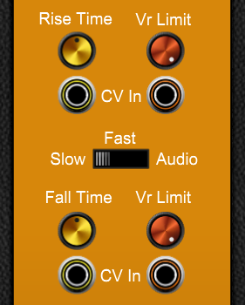

Time Base Multiplier Switch
Duration of 5 RC time constants.

Slow: x 1.0 second
Fast: x 0.1 second
Audio: x (1/720) second

Rise Time / Fall Time Knobs
The time taken to execute 5 RC time constants in the Rise or Fall directions. Note that increasing these time periods (by rotating the knob clockwise) lowers the cutoff frequency when used as a low-pass or high-pass filter. Values range from 0.1 x time base to 10.0 x time base, with value 1.0 at the 12 o’clock position.

Rise / Fall Vr Limit Knobs
These knobs are intended primarily to limit the note distance travelled by a portamento sweep. For example, if you wanted the start note of upward portamento bends to be 2 semitones below target, set the Rise Vr Limit knob to 0.167 V.
In the audio range, you can perform some interesting ‘West Coast’ style wave-shaping by using these controls, particularly in an asymmetric fashion.

Rise / Fall Time CV Inputs
The CV inputs under the Time knobs operate on a V/Oct basis. That is, for every increase in control voltage of 1 volt, the time period will be cut in half (thereby raising frequency by one octave). Similarly, a decrease of 1 volt will double the time period (and lowering frequency by one octave). In the audio range, you can make the filter outputs track the keyboard 100% by feeding the PITCH CV output into both Rise and Fall Time CV inputs.

Rise / Fall Vr Limit CV Inputs
The CV inputs under the Vr Limit knobs operate on an additive basis with the knob setting. The control voltage is added to the value of the knob setting and the result limited to the range 0 to 20 volts.

Input / Output Section
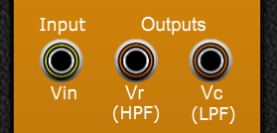

Vin Input Jack
This is simply the input for the CV or audio signals which you wish to process.

Vc (LPF) Output Jack (Right hand side)
This is the output you will use for 90% of applications. It represents the voltage across the capacitor in the RC circuit. V_{C} will slowly move towards V_{IN} at a rate determined by the Rise / Fall Time knobs / CV inputs. In the audio range, V_{C} represents a Low-Pass Filter (LPF) with a 6dB/Oct slope.

Vr (HPF) Output Jack (Middle)
The V_{R} output is effectively a voltage which represents (V_{IN} – V_{C}). If Vin suddenly jumps up, then Vr will immediately jump to that voltage difference. As Vc gets closer to Vin, then Vr gets closer to 0V. In the audio range, Vr represents a High-Pass Filter (HPF) with a 6dB/Oct slope.

The Science Bits

What’s all this R.A.T. stuff about?
I’m glad you asked! R.A.T. is an acronym for Real Analogue Transients. I’ve used a precise mathematical model of the physics involved in the charge/discharge curves of an RC circuit:
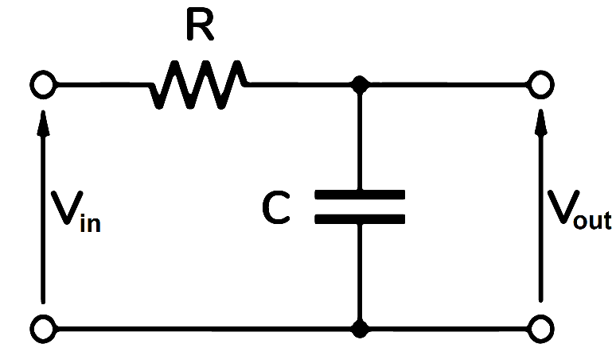
Figure 1 - RC Circuit
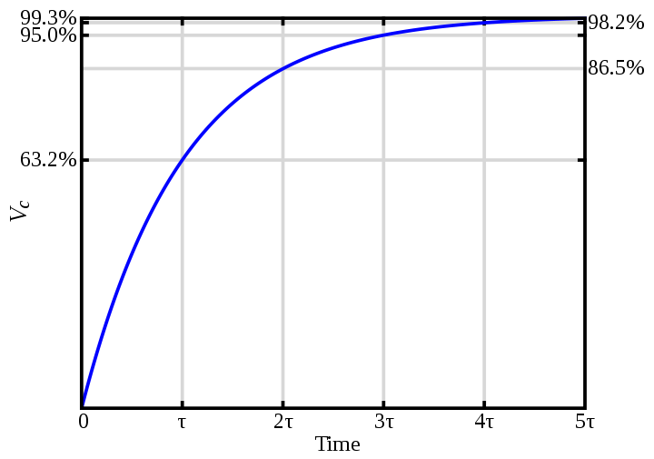
Figure 2- RC Charge Curve
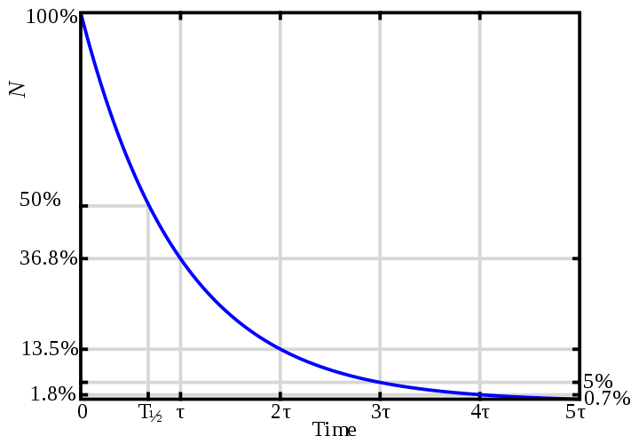
Figure 3 - RC Discharge Curve
There is a lot of information on the internet about the mathematics of these curves. Two related factors are extremely important to consider when using these charge / discharge curves in envelope generators, etc:
1. The RC Time Constant is calculated by multiplying the resistor value (in ohms) by the capacitor value (in farads). However, after one time period, the curve hasn’t reached its final ‘target’ value. In fact, it has only travelled 63.2% of the way there. Even after five time periods, it is still 0.7% away from its target value.
2. In fact, although the curve gets closer and closer with every time period elapsed, it never quite reaches its target value. This is known as a ‘horizontal asymptote’. As an analogy, imagine standing on one side of a room. Every second, you step 2/3 of the way closer to the wall on the opposite side of the room. How long will it take until the toe of your shoe makes contact with the wall? (See Zeno’s Dichotomy Paradox)
There is a third consideration which is specifically related to envelope generators, which is that the typical charge curve shape can sound unnatural when used for the Attack phase. The ear is usually much happier with a steeper curve and a more abrupt peak. Fortunately, synth manufacturers came up with a good solution for this problem. This involves ‘intercepting’ the Attack charge curve where it crosses a threshold voltage (the ‘Attack Peak’) and then reconfigures its time factor and ‘target’ voltage to perform the Decay / Sustain sections of the envelope. For example, if you set the Attack Peak threshold to be 85.6% of the full charge voltage, you would end up with a ‘bendy’ attack curve of 2 time periods, but which didn’t get anywhere close to the ‘flattening out’ phase of the curve from about 4 time periods onwards.
A fourth (!) consideration is that some software envelope generators have been implemented in a naïve fashion when it comes to switching between the Release and Attack phases on a new key press. In most analogue systems, the new note’s Attack phase will start from the same voltage level it had reached during the Release, and there are no abrupt discontinuities in voltage level. This allows you to ‘ride the envelope’ in a smooth way by playing a mixture of legato and staccato notes when playing monophonically – a hugely important factor when soloing on analogue monosynths. It also means that in analogue polysynths, decaying notes don’t get cut off abruptly when ‘voice stealing’ happens in the voice-allocation algorithm. On a Juno 6, for example, when voice stealing occurs on a sound with a slow attack, the new note will come in at the volume of the stolen note. Counter-intuitively, this is generally the desired behaviour; when you have a limited number of voices playing a pad sound, having them restart a slow attack will lead to a huge drop in volume and depth. Anyhow, when Big Rat is used as an envelope generator, the output voltage will always flow continuously from the Release phase into a new Attack phase without jumps, and DEFINITELY without returning to zero volts!

Big Rat - Principles of Operation
At its heart, the Big Rat consists of a simple state machine, a simple RC charge-discharge circuit and a pair of voltage comparators. Look up the NE 555 timer IC for a description of a similar system.
The state machine has three states of operation, with the labels “REST”, “ATTACK” and “DECAY”. The conditions for being in each state and transitioning between states being as follows:

REST state:
The input voltage of the RC circuit is set to 0V. Any residual voltage stored on the capacitor decays towards 0V at a rate determined the “Fall Time” knob.

GATE ON event:
If the Gate signal goes high when in the REST state, the ATTACK state is entered.

ATTACK state:
The input voltage of the RC circuit is set to +5V, plus an additional ‘overshoot’ voltage determined by the setting of the “Curve” knob. The voltage on the capacitor rises towards the input voltage at a rate determined by the “Rise Time” knob. When the voltage on the capacitor exceeds +5V, the DECAY state is entered.

DECAY state:
Depending on the setting of the Polarity switch, the input voltage of the RC circuit is set to either 0V (Unipolar) or -5V (Bipolar), minus an additional ‘undershoot’ voltage determined by the setting of the “Curve” knob. The voltage on the capacitor falls towards the input voltage at a rate determined by the “Fall Time” knob. When the voltage on the capacitor falls below 0V (Unipolar), the DECAY state is entered.

GATE OFF event:
If the gate signal goes low during the ATTACK or DECAY phases, the REST state is entered. The voltage on the capacitor decays towards 0V at the rate determined by the “Fall Time” knob. Note that there is no overshoot or undershoot voltage applied at this point, so the capacitor voltage decays asymptotically towards 0V, irrespective of the setting of the “Fall Curve” knob.

Curve Knob to Overshoot Voltage Conversion:
The “Curve” knobs have a range of values from 0 to 10. The curve overshoot / undershoot voltage is calculated according to the formula:
V_{over} = TimeFactor_{1T} * ((10.0 – CurveKnob) / 10.0)²
where:
TimeFactor_{1T} = (5.0 / (1 – e⁻¹)) – 5.0 = 2.9098835……
This means that with Curve = 0 (knob fully counter-clockwise), the capacitor voltage will intersect the +5V line after exactly one RC time period as set on the Rise Time Knob. With Curve in the 10 position, (fully clockwise) the capacitor voltage will never be greater than 5V and will sustain for as long as the gate signal is high. If you want to calculate Curve knob settings for other Time Factor multiplier values, then this is left as an exercise for the reader!
In Bipolar mode, V_{over} is multiplied by 2.0.

Smol Rat - Principles of Operation
At a basic level, Smol Rat is just an RC circuit which has two different time-constants based on whether the input voltage is greater than or less than the current capacitor voltage.
It was originally intended to be a portamento controller, so it has two special ‘gated’ modes which affect its behaviour whenever the Gate In signal is in either the ‘Low’ or ‘High’ state:
‘Hold’ mode will keep outputting the voltage on the capacitor from whenever the Gate signal was applied until it is released. In an electronic sense, the resistance value in the RC circuit becomes infinite whilst Hold is enabled.
‘Track’ mode will follow the input voltage exactly for as long as the Gate signal is active. Once released, normal slewing behaviour will resume again. In an electronic sense, the resistance value in the RC circuit becomes zero whilst Track is enabled.
The “Vr Limit” controls were introduced to limit the note distance travelled when portamento is enabled. They operate by calculating the difference in voltage between Vin and Vc. If this difference is greater than the setting on the Vr Limit knob, then Vc jumps immediately to (Vin – VrLimit) in the rising phase, or to (Vin + VrLimit) in the falling phase. When Vr Limit is set to 20, it has no effect. When set to 0, the output will track the input voltage precisely.
The Vr Limit controls can also be useful for wave-shaping of both LFO and audio-rate signals. They can be particularly useful for preserving some high-frequency content at the vertical edges of ramp or pulse waveforms.

Inspiration

The Big Rat
The Big Rat started out life as my attempt to recreate the simple envelope generators of the first synth I ever encountered – the Jen Synthetone SX-2000 (later rebadged as a Marlin machine).
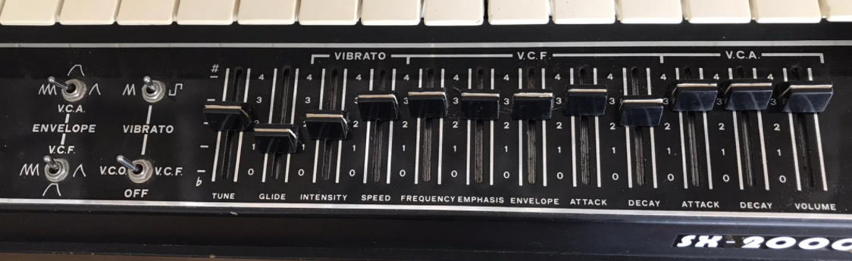
As you can see, the SX-2000 didn’t offer full ADSR control. Instead, three different modes were available:
ASR – The output voltage starts at 0 Volts. When a key is pressed, the voltage rises at the Attack rate until it reaches +5V. At this point, it sustains at +5V for as long as the key is held. On releasing the key, the voltage drops back to 0V at a rate set by the Decay control.
AD – The output voltage starts at 0 Volts. When a key is pressed, the voltage rises at the Attack rate until it reaches +5V. At this point, it immediately switches over to the Decay phase and the voltage drops back to 0V at a rate set by the Decay control.
AD Repeat – This is very similar to the AD shape. However, if you are still holding the key down when the voltage drops back to 0V, it will retrigger the Attack phase once again. The cycle repeats for as long as the key is held down.
All three envelope types were available on the independent envelope generators for VCF and VCA. Envelope depth can be controlled on the VCF via the “ENVELOPE” slider. I suppose you could also say that VCA envelope depth could be controlled via the “VOLUME” slider.
Another ‘70s synth which featured a similar envelope generator configuration was the PAIA Gnome kit synth. Note, however, that the VCA envelope on the Gnome does not offer the repeat function.
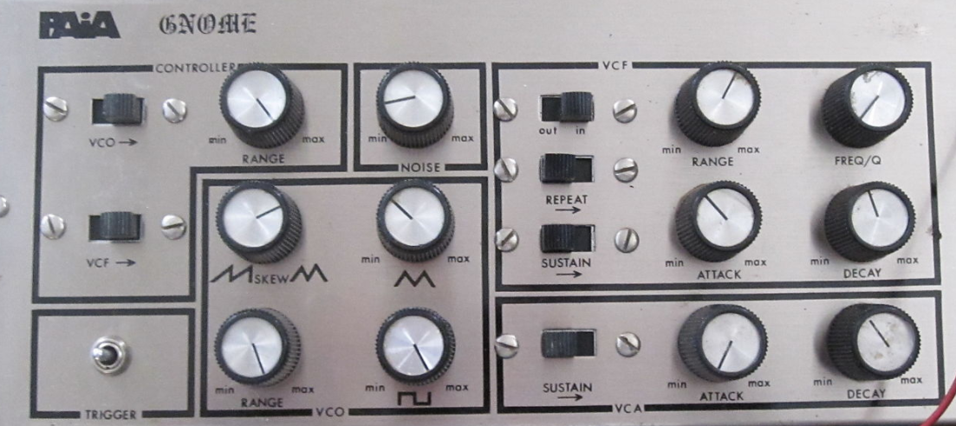

The Smol Rat

The Smol Rat was inspired by the Portamento circuit of the second synth I ever encountered – the Korg Micro Preset M-500.
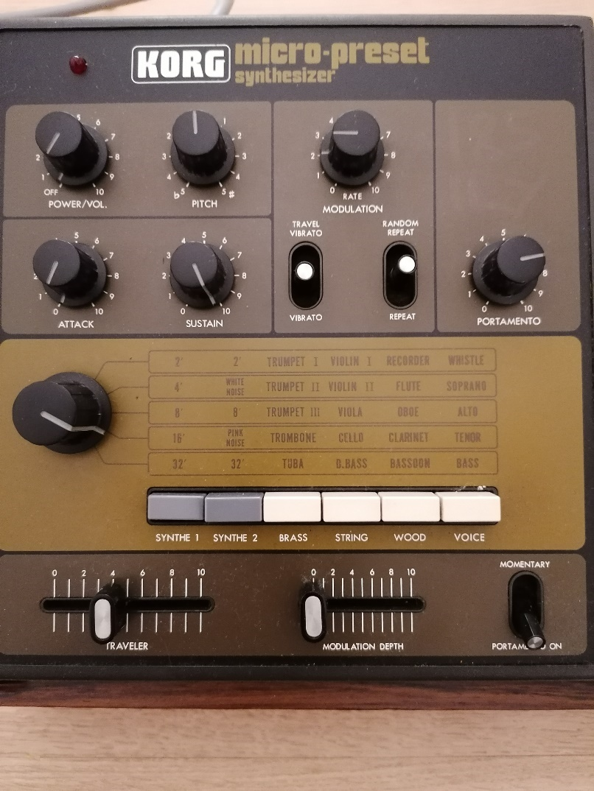
The Korg implementation of portamento on this particular synth was very idiosyncratic. This became especially apparent on the “SYNTHE 1” preset, which had a long release on its single envelope generator. After some investigation, it would appear that the Micro-Preset only had a single Sample & Hold circuit, which was intimately bound to the operation of the portamento.
Whenever you pressed a key, the portamento circuit would start to travel from the previously sampled keyboard voltage towards the newly-pressed key’s voltage. However, if you lifted your finger from the keyboard before it reached this new key’s control voltage, it would simply latch the portamento voltage at that point. It was quite easy to be left with a note decaying away which was between semi-tones on the keyboard. Also, if you used the “REPEAT” function, where the envelope was triggered by the LFO, the portamento would stutter its way up (or down) the keyboard in little steps, pausing to catch its breath every half-cycle. This bizarre operation can be emulated in the Smol Rat by placing the Gate Polarity Switch in the ‘Low’ position, and the Gate Function Switch in the ‘Hold’ position. The Gate In signal can come from the keyboard itself, or a LFO, to get that stuttering “REPEAT” effect.

