Zeit Year 50 Bundle from Dome Music Technologies

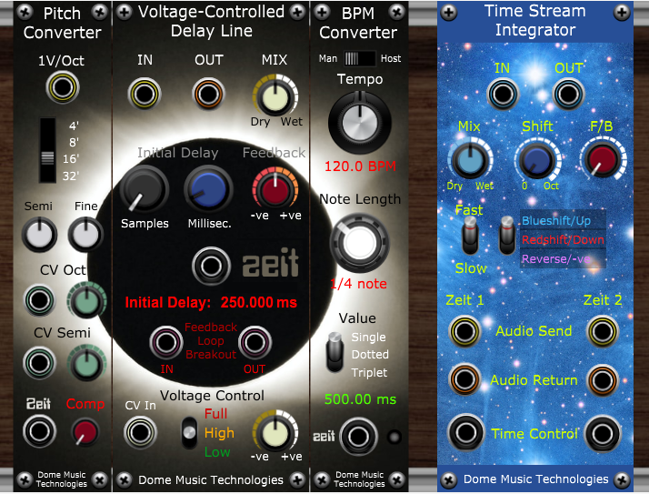

“It’s flux in the fabric of time!”
- World renowned co-producer Terry Viscomick

What Exactly IS the Zeit Year 50 Bundle?
I’m glad you asked! The Zeit Year 50 Bundle (hereafter referred to simply as “The Zeit Bundle”) is a collection of four modules which allow you to construct simple or complex time-delay based effects. The modules are:
The Zeit Voltage-Controlled Delay Line (AKA “The Zeit Module”). The Zeit Module is the beating heart of the bundle, performing all the time delay, modulation, feedback and mixing duties.
The BPM Converter, which calculates the delay times required to sync to the tempo you’re working with. Tempo can be set manually via the front panel, or automatically synced to the host DAW.
The Pitch Converter, which allows you to tune the delay time to the wavelength of a 1V/octave input. This opens up possibilities for physical modelling of acoustic instruments.
The Time Stream Integrator, which does some natty tricks with one or more Zeit Modules to create effects such as pitch shifting and even real-time reverse playback!

Why “Zeit”?
“Zeit” is the German word for “time”. It is also the name of an album by my all-time favourite band - Tangerine Dream:
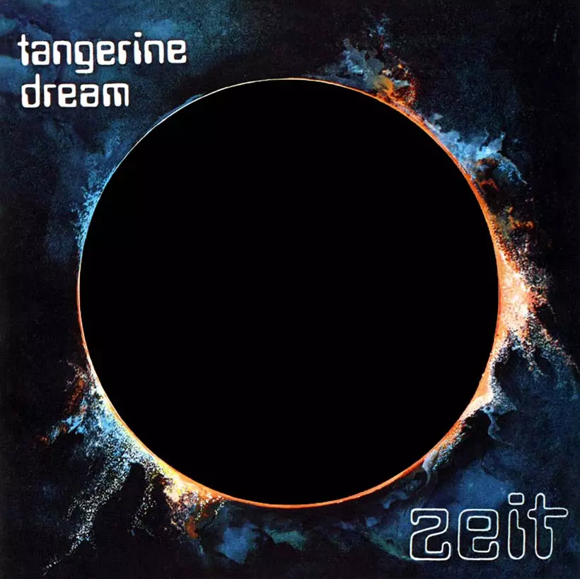
Zeit was released in August 1972 (hence “Zeit Year 50 Bundle”) and was the first TD album to feature the classic line-up of Edgar Froese, Chris Franke and Peter Baumann. In the pre-WWW days, I used to pronounce it as “zeet”, but have since learnt that it is closer in sound to “t-sight”.

The Zeit Voltage-Controlled Delay Line Module

Audio Input & Output Sockets and Dry / Wet Mix
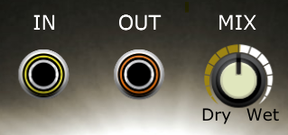
Zeit is a mono processor. If you want to process a stereo pair of signals, then you must run two instances of Zeit in parallel.
There’s not much to say about any of these panel features; your source signal should be connected to the IN socket, and the processed sound comes out of the OUT socket.
When the MIX knob is fully counter-clockwise, you hear 100% of the unprocessed input signal. When fully clockwise, you hear 100% of the delayed signal. When at the 12 o’clock position, you hear a 50:50 mix of the two. If you are using Zeit as a ‘send’ effect, ensure that the MIX knob is set to 100% wet.

Initial Delay and Feedback Controls
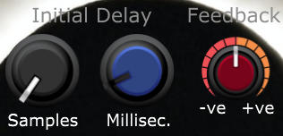
Zeit can delay a signal in the range 0 to 2,500 ms (0 to 2.5 seconds). The Millisec knob will set delay time in 1 ms increments. The Samples knob allows you to specify the number of sample periods to add to that. The Voltage Modular runs at 48,000 samples / second, so the Samples knob has a range of 0 to 47 samples within each millisecond.
When the delay is changed using the front panel knobs, there is a slew factor or ‘inertia’ applied to it, causing the delay to speed up or slow down like a physical tape echo unit.
The Feedback knob sets how much of the processed ‘wet’ signal is sent back to the input, creating decaying repeats. At the 12 o’clock position, no wet signal is recirculated. Turning the knob in a clockwise direction increases the positive feedback, up to a maximum of 100% (essentially ‘infinite repeat’). Turning the knob in a counter-clockwise direction increases the negative feedback, up to a maximum of -100% (essentially ‘infinite repeat’ with a signal which inverts its polarity on every pass).

The Temporal Displacement Override Input (AKA “The Zeit Socket”) and Initial Delay Display
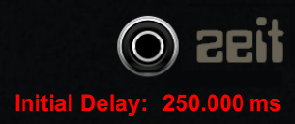
The Zeit Socket allows voltage control of the Initial Delay time by an external device. The three helper modules in the bundle all use a “Zeit Output” socket which drives the Zeit module according to their needs.
The Zeit input works on a 1V / 1 second (1 mV / 1 ms) of delay basis. Valid values are 0.0 V to 2.5 V. Any values outside of this range are clipped at 0.0 V or 2.5 V. During development, the Zeit input would allow negative voltages, but this functionality was withdrawn after Dome Music Technologies were handed a cease-and-desist order by the High Council of Gallifrey.
Unlike the Initial Delay knobs, there is no slew factor / inertia applied to the Zeit Socket. If the input voltage changes instantly, the delay time will also jump instantaneously to the new value. This can lead to clicks and other types of distortion, but the helper modules have been designed to avoid the generation of artifacts in the vast majority of use cases.
The Data70 font (and lower-case “z”) was employed as a respectful tribute to the cover of Tangerine Dream’s “Zeit” album.
The Initial Delay Display provides a readout of the Initial Delay, as set on the front panel knobs. If there is a connection to the Zeit Socket, the delay value is displayed as “--------” and the two Initial Delay knobs are disabled.

Feedback Loop Breakout Sockets
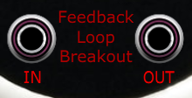
The Feedback Loop Breakout Sockets allow you to insert additional processing modules in the feedback loop of Zeit. As an example, you could place a low-pass filter in the feedback loop so that repeating echoes become progressively dampened over time.
The breakout OUT socket will always output the delayed / ‘wet’ signal at a level determined by the Feedback knob.
If nothing is connected to the breakout IN socket, Zeit will act as normal; the recirculated feedback sound and the ‘wet’ mix on the main output socket will be clean and ‘digitally perfect’.
If the feedback signal is processed then sent back into Zeit through the breakout IN socket, you will get a more effected signal being sent to the main output, and recirculated through the delay line.
The signals exiting the breakout OUT socket and entering through the breakout IN socket are restricted to the range +/- 10.0V. This is done to prevent runaway positive feedback building into a ridiculously loud signal, whilst still enabling those retro tape-echo saturation effects beloved of B-movies.

The Voltage Control Section
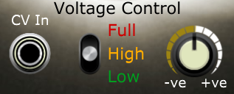
Zeit allows external voltage control of delay time. The control signal will further modify the delay time set on the Initial Delay knobs (or controlled via the Zeit Socket).
The control voltage source should be connected to the CV In socket.
The scale switch allows you to select one of three control ranges:
Low: 1 volt = +10 sample periods of delay. Ideal for subtle chorus effects.
High: 1 volt = +10 milliseconds of delay. Suited to more extreme modulation effects, like flanging.
Full: 1 volt = +250 milliseconds of delay. If the initial delay is set to mid-range (1,250 ms), the full range of delay values (0 to 2,500 ms) can be commanded from a +/-5V CV signal.
The attenuation knob allows linear scaling of the CV input. In the 12 o’clock position, the CV input has zero effect. At the fully-clockwise position, you get 100% positive CV effect. At the fully counter-clockwise position, you get 100% negative CV effect.
Similar to the Zeit Socket, the CV input does not apply any form of slewing to the CV signal. Instantaneous jumps in CV voltage will perform instantaneous jumps to a new delay time. Be aware that this can lead to clicks, aliasing and other audio artifacts.

The BPM Converter Module
The BPM Converter is a ‘helper module’ which extends the functionality of Zeit to perform tempo-synced delays.

Manual / Host Switch, Tempo Control Knob and Tempo Readout
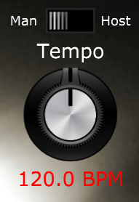
The Man / Host switch sets the operating mode of the module. In the “Man” (manual) position, the Tempo is set by the Tempo Control Knob below. In the “Host” position, the tempo is set by the host DAW, or the tempo setting of the Voltage Modular standalone application:
When switched to the “Host” position, the Tempo Control Knob is disabled.
The Tempo Control Knob allows manual setting of tempo in the range 20 BPM (Beats Per Minute) to 220 BPM.
The Tempo Readout displays the current tempo in BPM, whether set by the knob or host sync.

Note Length Selector
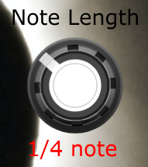
The Note Length Selector knob allows you to specify the note duration in the range 1 whole note down to 1/64th note. In formal musical terms, one ‘beat’ is equivalent to one quarter ‘note’. Don’t ask me why this is so – it just IS. For example, at a tempo of 120 BPM, there will be 30 whole notes (duration 2 seconds) in the space of one minute, and 120 ¼ notes (duration 500 ms).

Note Value Selector and Delay Time Readout
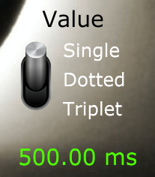
As well as having delays timed to standard single beat measures, you also have the option of specifying ‘dotted’ notes and ‘triplet’ time.
Delay times are multiplied as follows:
Single = x 1.0
Dotted = x 1.5 (3/2) Two repeats within the same duration as three single beats.
Triplet = x 0.667 (2/3) Three repeats within the same duration as two single beats.
One of my personal favourite effects is to have two delays panned left and right, with one set to ¼ note and the other set to a dotted 1/8 note.
The Delay Time Readout displays the delay time calculated from the panel settings. Note that a slewing factor is applied to the delay time output so that transitions from one tempo to another do not lead to clicks. This is not reflected in the displayed value, which always shows the target delay time, not necessarily the current value. Try varying the Tempo Knob and listening to the delayed signal slow down and speed up smoothly.

The Zeit Output Socket and Overflow LED
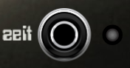
The Zeit Output Socket is what enables the BPM Converter to set the delay time of a connected Zeit Module:
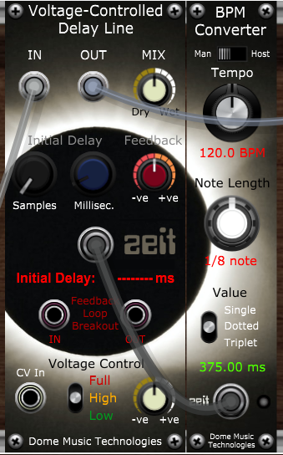
Note that, when the Zeit Socket is connected, the Initial Delay readout shows “-------”and the Initial Delay knobs are disabled.
The Zeit Overflow LED lights up red whenever the calculated delay value is greater than 2,500ms. This can happen, for example, when a Single Half Note is selected at a tempo lower than 48 BPM.

The Pitch Converter
The Pitch Converter takes a 1V / Octave pitch input and converts it into a delay time which corresponds to one period of an oscillator at that pitch. For example, if you played A=440Hz on the keyboard, the Pitch Converter would command Zeit to set a delay time of 1 sec / 440 Hz = 2.2727 ms.

1 Volt / Octave Input
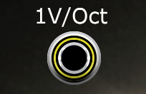
This is where you would normally patch in the keyboard Pitch CV. If you feed white noise into the connected Zeit Module and turn up the feedback, you can ‘play’ the noise like an oscillator. Of course, any CV source can be used in place of the keyboard. We’re in the modular world, after all!

Octave Selector and Tuning Controls
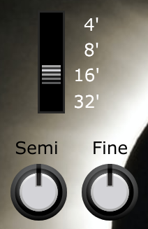
Like most other oscillators, you can select which octave (or ‘footage’) you want to play in. The pitch of the signal coming out of Zeit will be in the same octave as the stock Cherry Audio Oscillator.
The Semi Tune Knob allows you to detune the pitch of the delay line by +/- one octave in semitone steps. The Fine Tune Knob allows you to specify fine detune within the range +/- one semitone.

Octave and Semitone CV Inputs
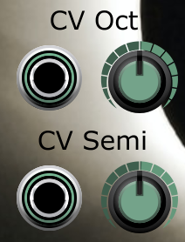
There are two CV inputs for further modulating the pitch.
The CV Oct input will raise the pitch by an octave for a +5V input signal
The CV Semi input will raise the pitch by a semitone for a +5V input signal.
The attenuator knobs are bipolar, with zero effect at the 12 o’clock position.

Zeit Output Socket and Feedback Loop Compensation Knob
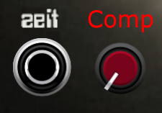
The Zeit Output Socket connects to the Zeit Socket of the controlled Zeit Module (That’s enough Zeits for one sentence – ed).
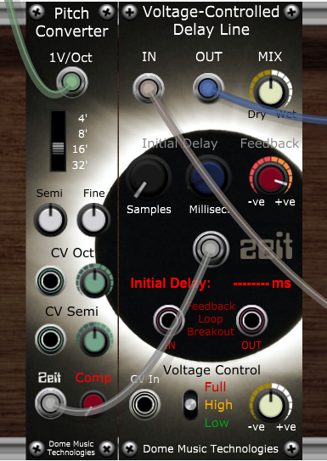
The Comp knob comes into play when you have modules inserted into the Feedback Loop Breakout circuit. Every module added to the feedback loop adds an extra sample period to the delay time. For longer delays, an extra 1/48,000th of a second has a negligible effect. However, at audio rates, one sample period accounts for a significant fraction of the oscillation period. As well as throwing off tuning, note scaling is also affected by these additional delays.
Compensation can be specified as 0 to 10 sample periods, in steps of 1 sample period. This allows you to have a chain of up to 10 modules in the feedback loop whilst staying tuned to 12-TET concert pitch.

The Time Stream Integrator
The Time Stream Integrator (hereafter referred to as the “TSI”) is a ‘helper module’ which extends the functionality of Zeit to perform real-time pitch shifting and reversing. Pitch-shifting can be upwards or downwards in the range +/- one octave. Reversal can be performed on ‘packets’ of input audio of duration 500 ms (‘Fast’) or 1,250 ms (‘Slow’).
It can operate with just one Zeit module, in which case the resulting output is glitchy and clicky, reminiscent of early digital effects unit. Alternatively, it can coordinate the activities of two Zeits for a smoother-sounding output. This is achieved by crossfading from one channel to the other, perfectly timed so that discontinuities in a channel’s output only occur when the channel’s amplitude is at the zero point.

Audio Input and Output
The TSI audio input and output should be used when operating two Zeits in smooth (crossfading) mode. If you wish to run just one Zeit in ‘early digital’ (glitching) mode, then it is more appropriate to use the Zeit’s own audio sockets, Mix Knob and Feedback Knob.
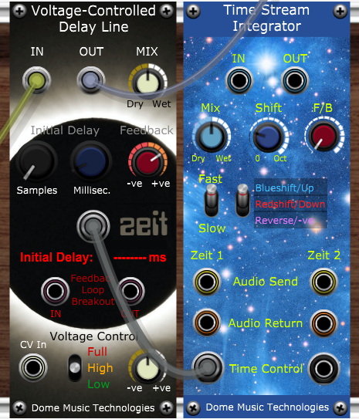
Figure 1 - 'Early Digital' mode using one Zeit

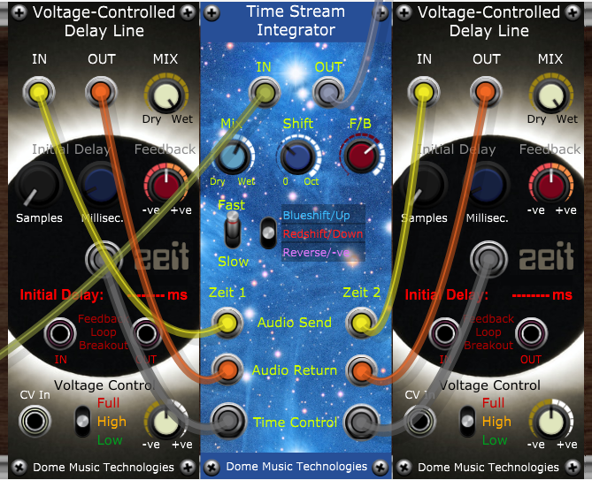
Figure 2- Two Zeits operating in smoothed (crossfading) mode.

When operating in smoothed mode, it is necessary to set each Zeit’s Mix Knob to “100% wet” and its Feedback Knob to the zero (12 o’clock) position. It is also recommended that nothing is connected to either Zeit’s CV In socket.

Mix, Shift and Feedback Knobs
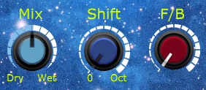
The Mix Knob controls the overall Dry / Wet mix of the TSI’s output. It is 100% dry when fully counter-clockwise, 100% wet when fully clockwise, and a 50:50 mix at the 12 o’clock position.
The Shift Knob controls the amount of pitch shift when the TSI is operating in Up or Down shift mode. Shift amount ranges from 0, when fully counter-clockwise, to one octave (12 semitones) when fully clockwise. When the TSI is operating in Reverse mode, the Shift Knob has no effect and is disabled.
The F/B (‘Feedback’) Knob controls the amount of processed signal which is recirculated back to the input of the TSI. Note that the F/B Knob on the TSI is unipolar, unlike the Feedback Knob on Zeit. When fully counter-clockwise, none of the processed signal is recirculated. When fully clockwise, 100% of the processed signal is fed back to the input.

Processing Rate and Mode Selector Switches
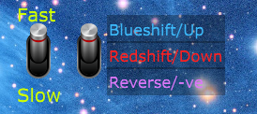
The Mode Selector Switch determines the operating mode of the TSI:
Blueshift/Up Mode performs an upwards pitch shift from 0 to +12 semitones (one octave).
Redshift/Down Mode performs a downwards pitch shift from 0 to -12 semitones (one octave).
Reverse/-ve Mode performs backwards playback without any pitch shift.
The Processing Rate (Fast/Slow) Switch determines the length of input audio ‘packet’ on which the processing is performed.
 | Shift Up / Shift Down | Reverse
Fast | 200 ms | 500 ms
Slow | 500 ms | 1,250 ms

The Zeit Connection Sockets
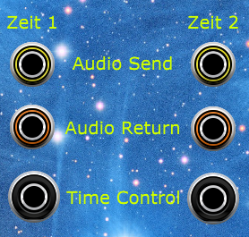
Each connected Zeit Module must be cabled-up in the following way (see Figure 2- Two Zeits operating in smoothed (crossfading) mode.):
Audio Send on the TSI goes to Audio IN on the Zeit Module
Audio Return on the TSI goes to Audio OUT on the Zeit Module
Time Control on the TSI goes to the Zeit Socket on the Zeit Module
Note that the colours of the sockets’ rings are the same for each cable’s source and destination. It can aid clarity if you also select the same colours for the cables.

© Grant Middleton, Dome Music Technologies, August 2022

